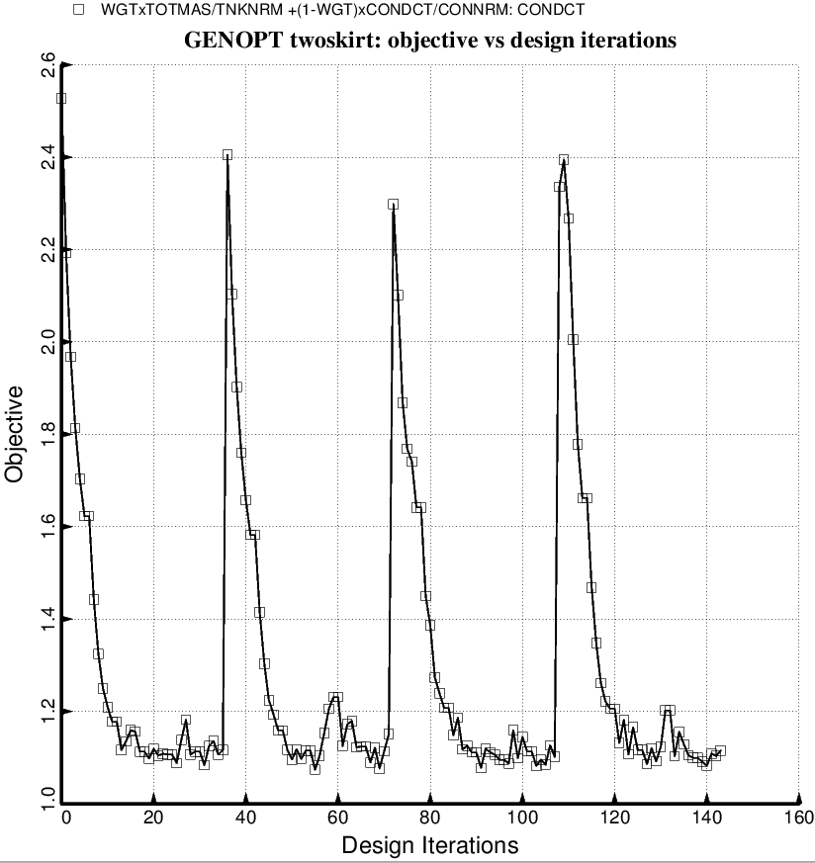

Fig. 22a (new) Evolution of the objective during a partial execution of SUPEROPT for the specific case, “twoskirt” obtained with the use of the “temporary” versions of bosdec (bosdec.tank2.density.var) and addbosor4 (addbosor4.tank2.density.var). The “twoskirt” input variables are listed in twoskirt.BEG and the decision variables are listed in twoskirt.DEC. This and the next several slides pertain to the specific case called “twoskirt”. In order to treat “twoskirt” the GENOPT software had to be modified to permit more decision variable candidates.

