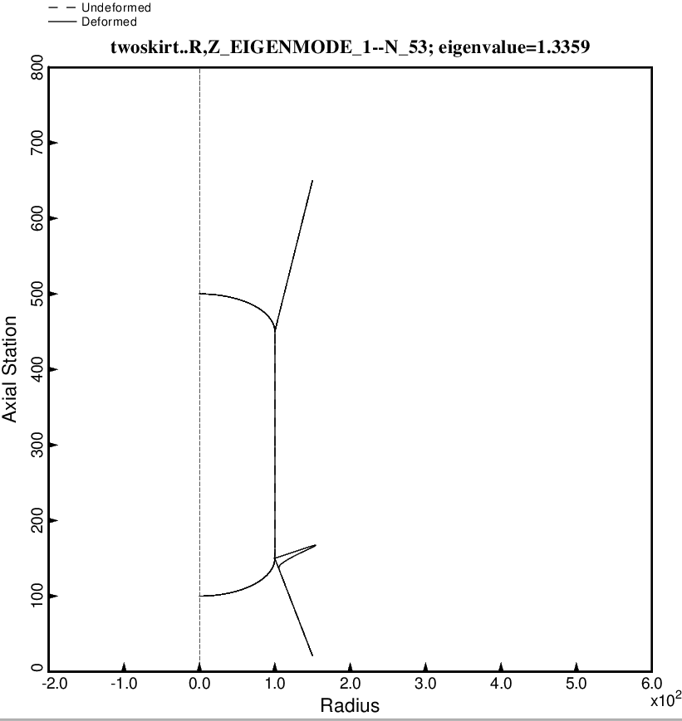

Fig. 29 (new) Nonsymmetric buckling modal deformations of the optimized tank/skirt system determined with use of the “temporary” versions of bosdec (bosdec.tank2.density.var) and addbosor4 (addbosor4.tank2.density.var). The inertial loading is 10g AXIAL acceleration. For n = 53 circumferential waves the lowest buckling load factor corresponds to short-axial-wavelength buckling of the forward part of the aft skirt.

