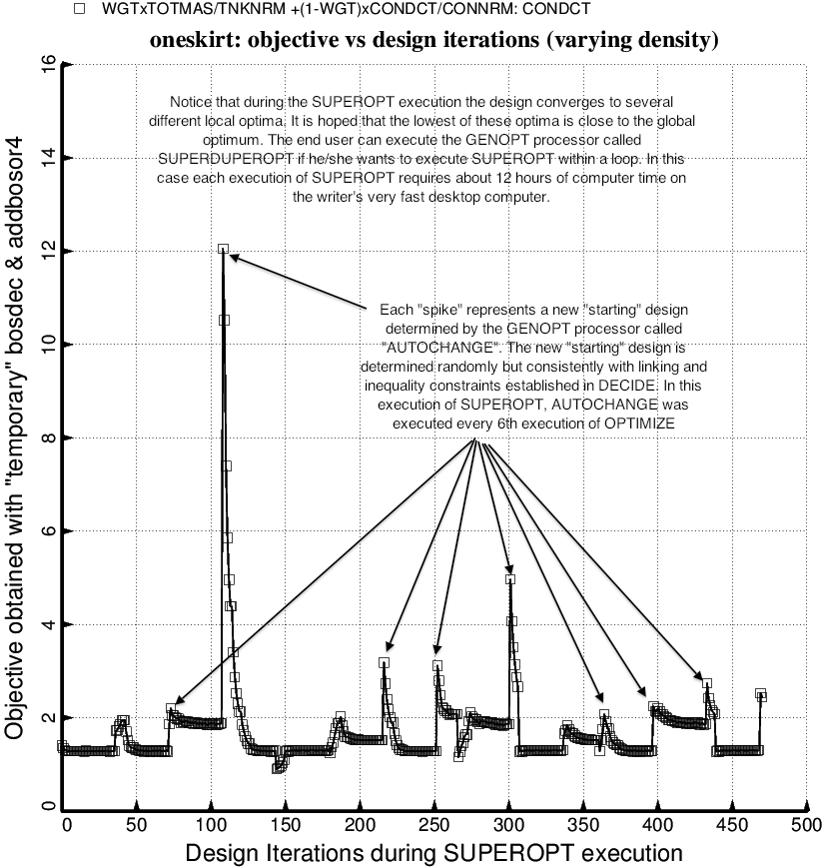

Fig. 2a (old) Evolution of the objective during an execution of SUPEROPT for the specific case, “oneskirt” obtained with the use of the “temporary” versions of bosdec and addbosor4. The decision variables are listed in Table 4.

