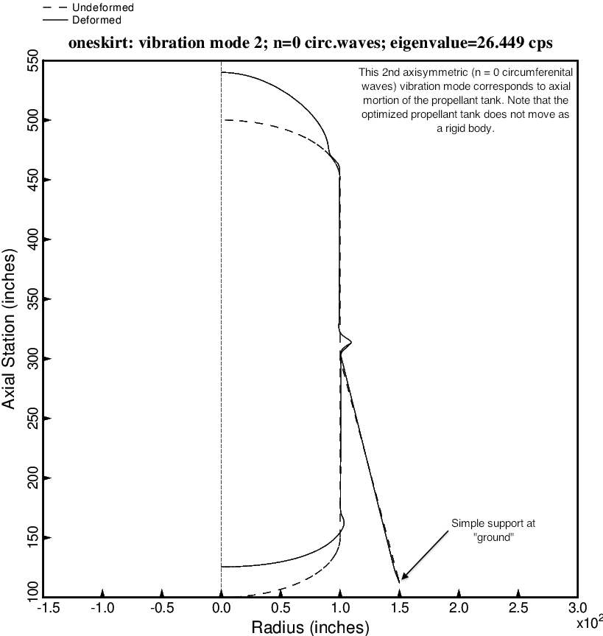

Fig. 4 (old) Axisymmetric axial vibration mode for the optimized tank/skirt system determined with use of the “regular” or “permanent” versions of bosdec (bosdec.tank2) and addbosor4 (addbosor4.regular).

