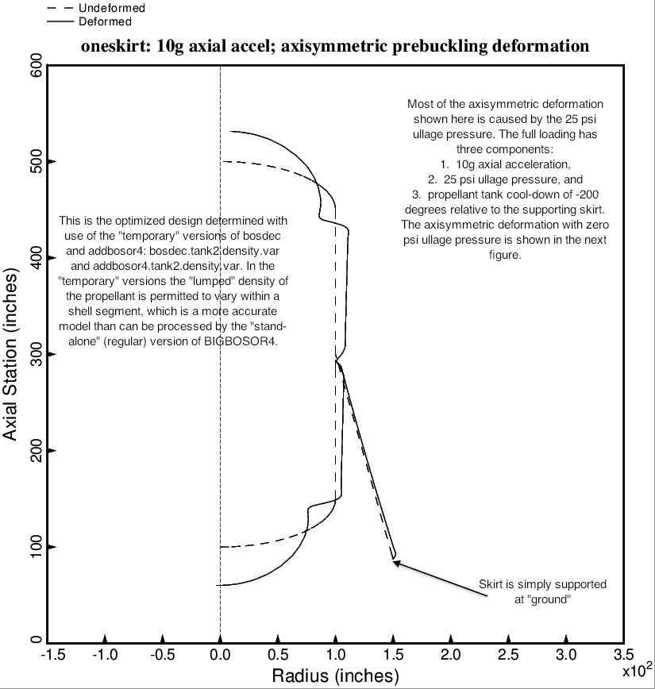

Fig. 7 (old) Axisymmetric prebuckling deformations of the optimized tank/skirt system determined with use of the “temporary” versions of bosdec (bosdec.tank2.density.var) and addbosor4 (addbosor4.tank2.density.var). The g-loading is AXIAL.

