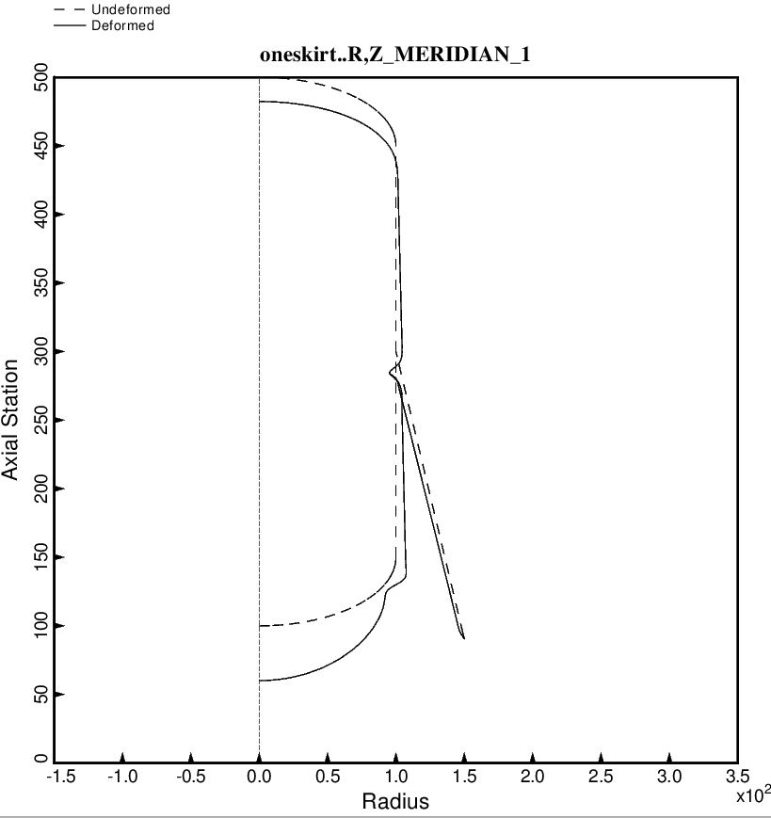

Fig. 8 (new) Axisymmetric prebuckling deformations of the optimized tank/skirt system determined with use of the “temporary” versions of bosdec (bosdec.tank2.density.var) and addbosor4 (addbosor4.tank2.density.var). In this case the ullage pressure and the tank cool-down temperature are both zero. Compare with the previous two figures. The g-loading is AXIAL.

