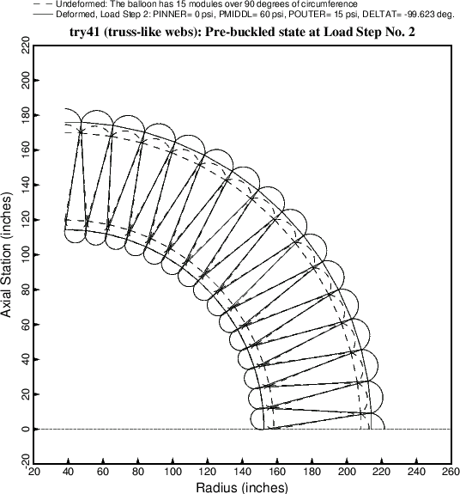

Fig. 10 Uniform pre-buckled state of the balloon subjected to the loads in Load Step No. 2, that is, after the outer pressure, POUTER, has been applied. In this example POUTER = 15 psi, and the wall cross section has been optimized. The results for POUTER = 15 psi and factor of safety for buckling of 1.0 are listed in Table 17. Note: plots of this type, generated via a BIGBOSOR4 input file called “try4.BEHX2”, can no longer be obtained without modifying SUBROUTINE BEHX2 as described in **Item 8** of **Section 8**.