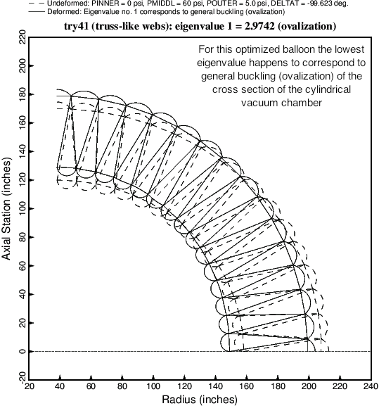

Fig. 11 The critical buckling mode and load factor (eigenvalue) corresponding to the optimized balloon cross section (Table 14). In this case the critical buckling mode, that is, the buckling mode associated with the lowest eigenvalue, happens to correspond to general buckling (ovalization) of the entire cross section of the cylindrical vacuum chamber. The buckling modes corresponding to some slightly higher eigenvalues are displayed in the next three figures.