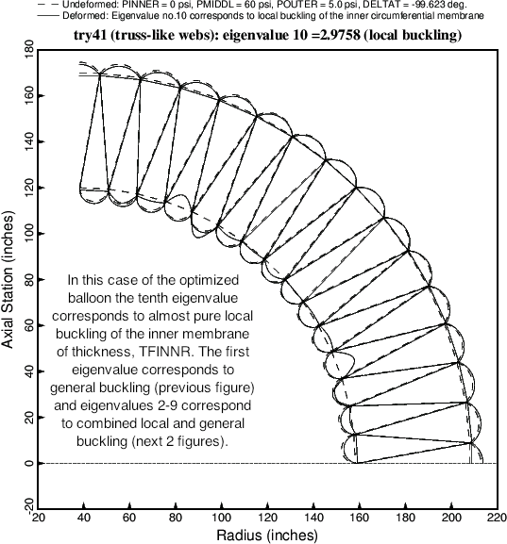

Fig. 12 The tenth buckling mode and load factor (eigenvalue) corresponding to the optimized balloon cross section (Table 14). The tenth buckling mode is the first mode that is almost entirely local buckling. There is a tiny component of general buckling (ovalization) contained in this tenth buckling mode. The buckling modes corresponding to the second and third eigenvalues are displayed in the next two figures.