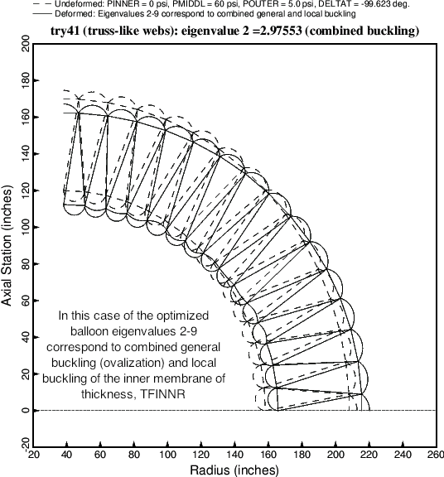

Fig. 13 The second buckling mode and load factor (eigenvalue) corresponding to the optimized balloon cross section (Table 14). The second buckling mode is a combination of local and general buckling.