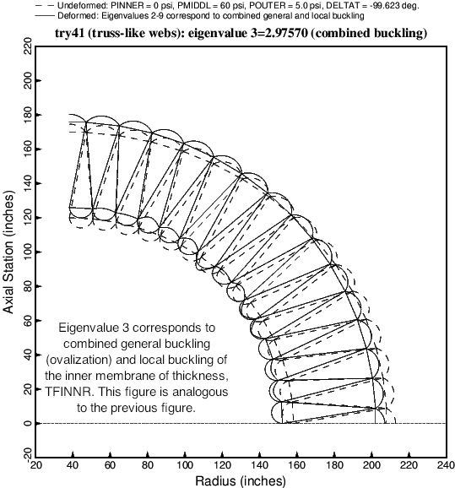

Fig. 14 The third buckling mode and load factor (eigenvalue) corresponding to the optimized balloon cross section (Table 14). The third buckling mode, like the second displayed in the previous figure, is a combination of local and general buckling.