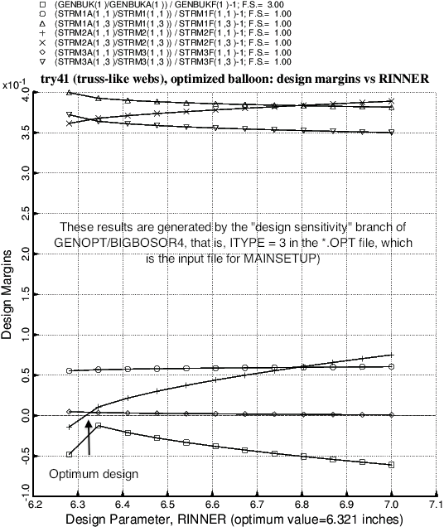

Fig. 16 Design sensitivity analysis of the optimized balloon (Table 14). This figure is produced following an analysis type, ITYPE = 3, in the \*.OPT file (input for the GENOPT processor called MAINSETUP). In this case the design sensitivity with respect to the decision variable, RINNER, is determined. As is often the case for optimized designs, several design margins are critical (near zero) in the neighborhood of the optimum value of RINNER. (RINNER is the radius of curvature of the inner curved membrane in the balloon wall, as indicated in Fig. 1.)