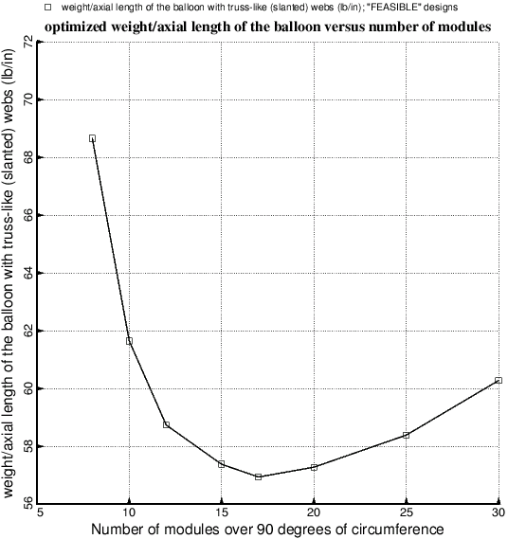

Fig. 18 Optimized weight/axial length as a function of the number, NMODUL, of modules in the model. These results required many days to obtain because the SUPEROPT runs required, especially for the models with 20 or more modules, long execution times on the computer.