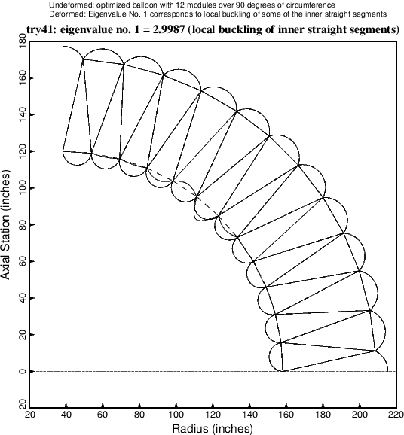

Fig. 19 Critical buckling mode of the optimized balloon with 12 modules over 90 degrees of circumference. In this particular case the critical (lowest) eigenvalue happens to be associated with a local buckling mode.