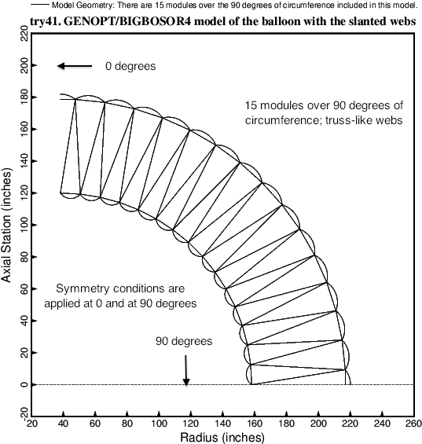

Fig. 2 Cross section of the double wall of the cylindrical vacuum chamber with **truss-like (slanted) webs**. The pressure inside the inner wall is PINNER; the pressure outside the outer wall is POUTER; The pressure between the inner and outer walls is PMIDDL. PMIDDL > POUTER > PINNER. Buckling of and stress in this configuration is computed with use of the BIGBOSOR4 computer program. The wall is optimized (minimum weight) with the use of the system of computer programs called “**GENOPT/BIGBOSOR4**” [2, 6, and 8 – 11].