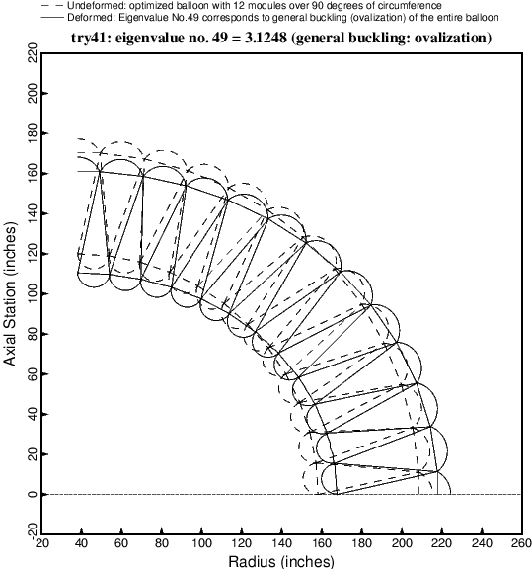

Fig. 20 49th buckling mode of the optimized balloon with 12 modules over 90 degrees of circumference. In this particular case the 49th eigenvalue happens to be associated with the general buckling (ovalization) mode.