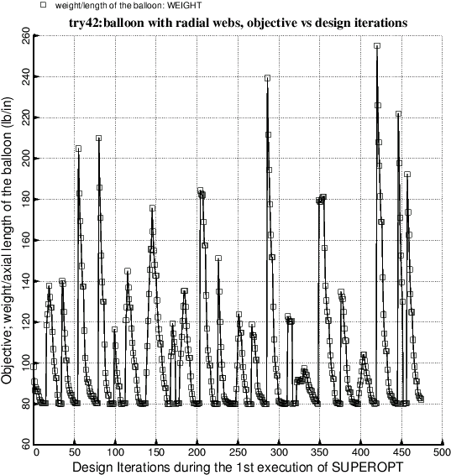

Fig. 21 This figure is analogous to Fig. 6b. Optimization of the balloon with **radial webs** (Fig.1). There are 15 modules over 90 degrees of circumference. In this first execution of SUPEROPT the radii, RINNER and ROUTER, are not decision variables.