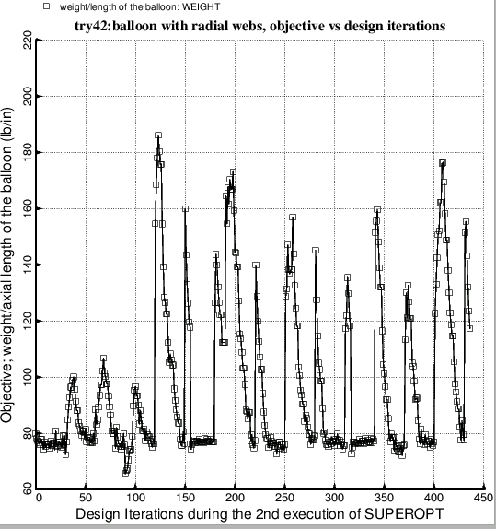

Fig. 22 This figure is analogous to Fig. 7. Optimization of the balloon with **radial webs** (Fig.1). In this second execution of SUPEROPT the radii, RINNER and ROUTER, are decision variables.