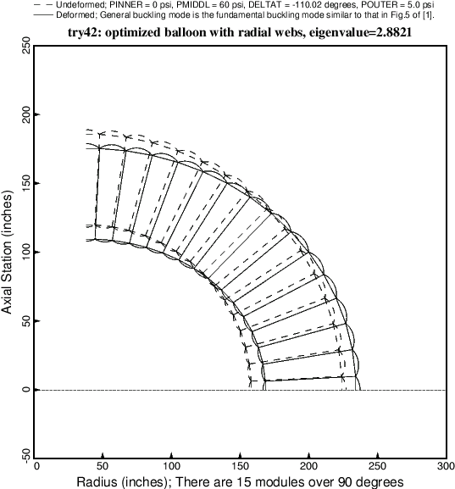

Fig. 23 This figure is analogous to Fig. 11. The critical buckling mode corresponds to general buckling (ovalization).

This general buckling mode is similar to the general buckling mode shown in Fig. 5 of [1]. Notice, however, that there is less shearing deformation in the plane of the wall cross section at 45 degrees than exists in Fig. 5 of [1].