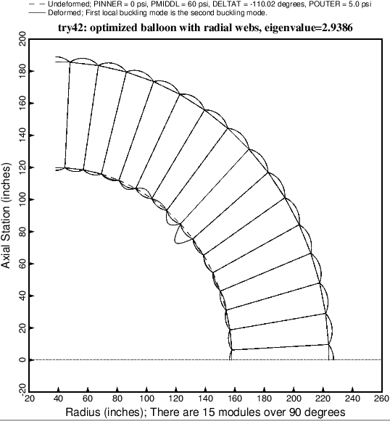

Fig. 24 This figure is analogous to Fig. 12. Local buckling of the optimized balloon with **radial webs**. At the optimum design the local buckling load factor, 2.9386, which corresponds to eigenvalue no. 2, is fairly close to the general buckling load factor, 2.8821, shown on the previous slide.