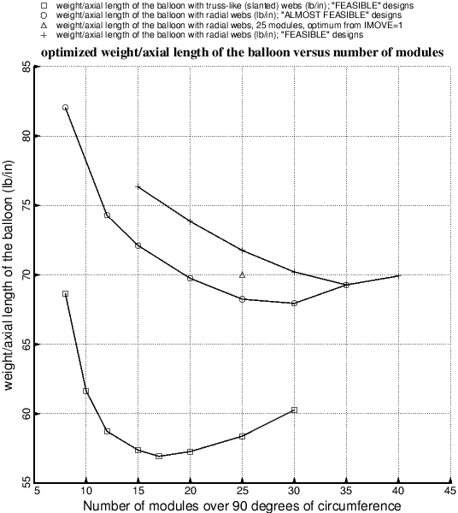

Fig. 25 Optimized weight of the balloons with the truss-like (slanted) webs (trace no. 1) and optimized weight of the balloons with the radial webs (traces 2,3,4) as functions of the number of modules over 90 degrees of circumference of the cylindrical vacuum chamber. The best design of the balloon with the truss-like webs weighs significantly less than the best design of the balloon with the radial webs. The data points in this figure required about 3 weeks of calendar time to produce because of long computer runs, especially for the designs with more than 15 modules. An “ALMOST FEASIBLE” design is a design in which the most critical margin is greater than –0.05 and less than –0.01. A “FEASIBLE” design is a design in which the most critical margin is greater than –0.01.