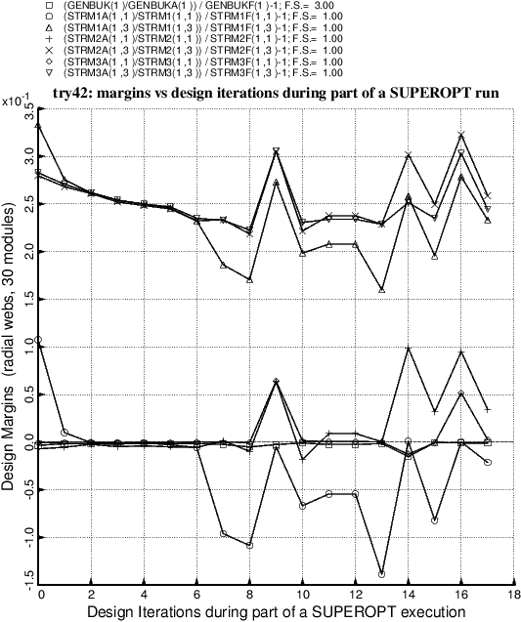

Fig. 27 Optimization of the balloon with radial webs and 30 modules. This execution of SUPEROPT aborted at Design Iteration No. 18 because of failure of convergence of the nonlinear pre-buckling equilibrium solution during Load Step No. 1, for which the applied loads are PINNER, PMIDDL, and DELTAT [the “fixed” (non-eigenvalue) loads]. At the time this run was made SUBROUTINE BEHX1 included only two attempts to solve the nonlinear problem (**Try no. 1** and **Try no. 2** identified in **Item 9** listed in **Section 8**). Introduction of a third attempt, **Try no. 3**, solved the problem.