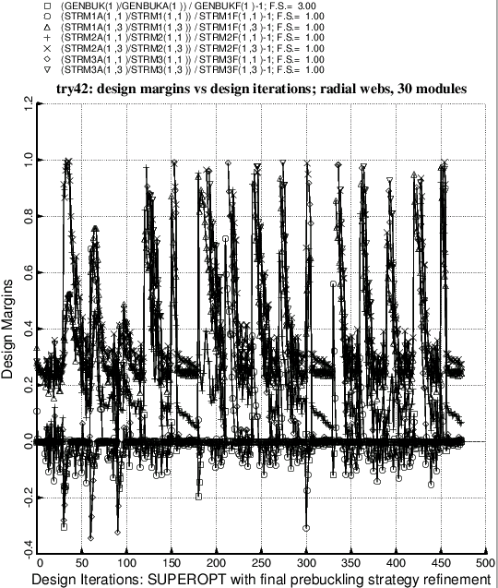

Fig. 27c Optimization of the balloon with radial webs and 30 modules after the introduction into SUBROUTINE BEHX1 of **Try no. 3** in the strategy to solve the nonlinear pre-buckling equilibrium equations. (See **Item 9** listed in **Section 8.**) This execution of SUPEROPT ran to a normal termination at about 470 design iterations. Compare with Fig. 27. Ordinarily one does not bother with plots of design margins subsequent to a completed execution of SUPEROPT because the plot, containing results from about 470 design iterations, is so messy.