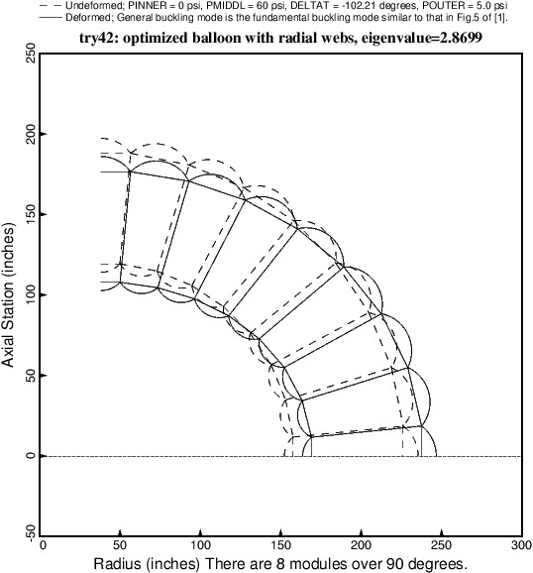

Fig. 28 General buckling of the optimized balloon with radial webs and 8 modules.