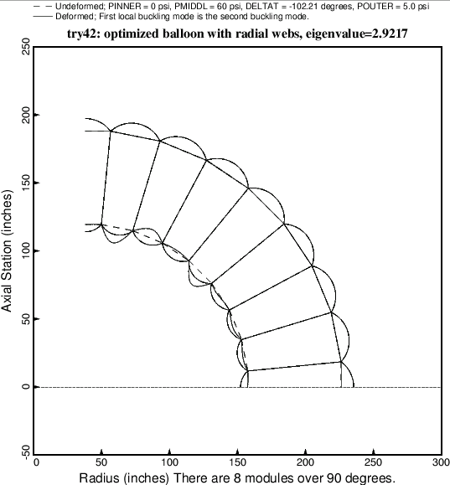

Fig. 29 Local buckling of the optimized balloon with radial webs and 8 modules. This local buckling mode corresponds to eigenvalue no. 2.