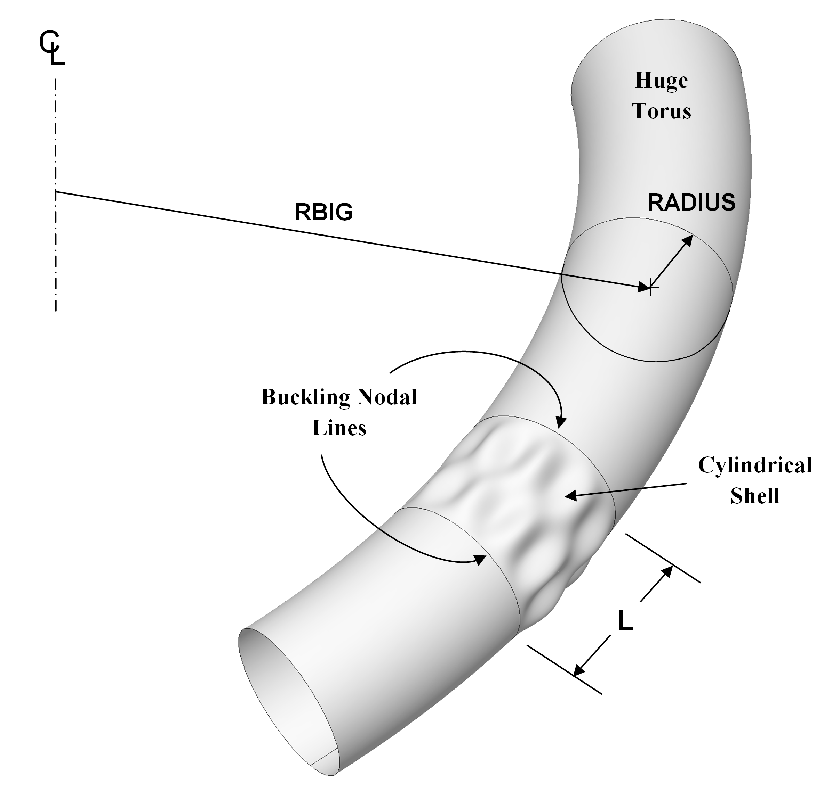

Fig. 3 **Schematic of a “huge torus” model [7-9]**. This figure was created by Robert P. Thornburgh [9]. For most “huge torus” models [7], a good choice of RBIG is RBIG = 100xL/π. The double-walled cylindrical balloons studied here have RADIUS = 120 inches to the inner wall of the double-walled vacuum chamber. For the “true prismatic” shell model the kinematic relationships introduced recently into BIGBOSOR4 [8] correspond essentially to RBIG = infinity. In the “huge torus” [7] and “true prismatic shell” [8] models what is the axial coordinate in the usual model of a cylindrical shell becomes the circumferential coordinate in the “huge torus” model, and what is the circumferential coordinate in the usual model of a cylindrical shell becomes the meridional coordinate in the “huge torus” model. This “trick” of exchanging coordinates makes it possible to analyze prismatic shells as if they were shells of revolution. Hence, the details of the cross section of the double-wall of the balloon are retained, and a shell-of-revolution code such as BIGBOSOR4 can be used to analyze the cylindrical vacuum chamber that is not, in the ordinary sense, a shell of revolution. The wall characteristics need not be smeared, and both local and general buckling modes can be obtained.