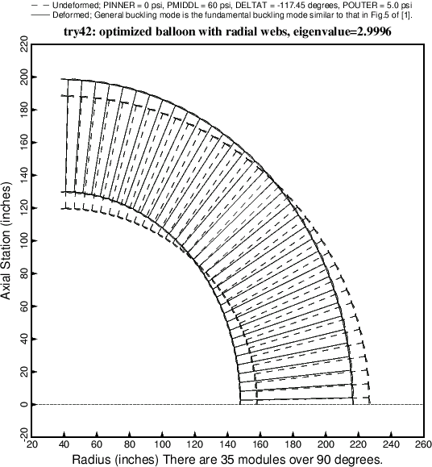

Fig. 30 General buckling of the optimized balloon with radial webs and 35 modules.