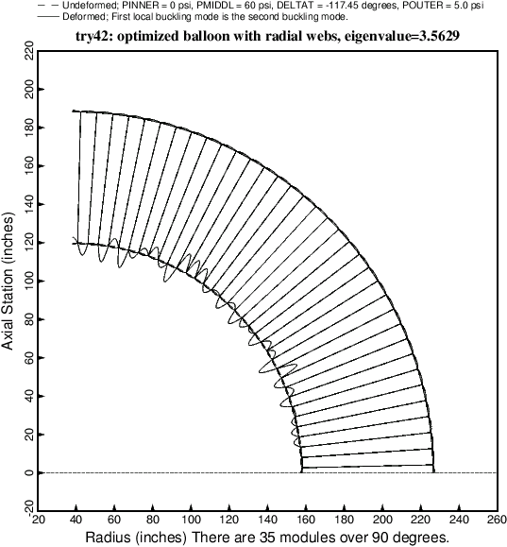

Fig. 31 Local buckling of the optimized balloon with radial webs and 35 modules. This local buckling mode corresponds to eigenvalue no. 2. Eigenvalues 3, 4, 5,,… are all very close to Eigenvalue No. 2 and all of them correspond to buckling of the inner straight segmented membrane of thickness, TFINNR.