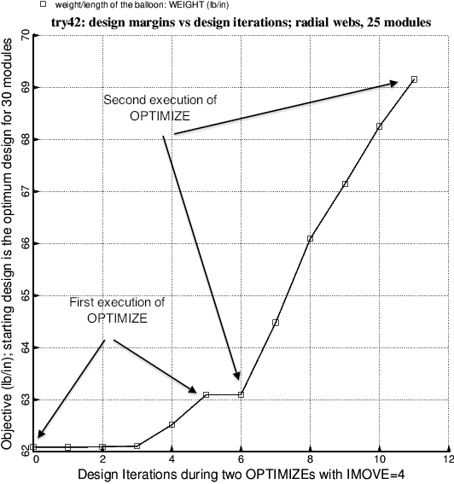

Fig. 32 Optimization of the balloon with the radial webs and 25 modules. The “move limit” index, IMOVE, is set equal to 4, which restricts the change of each decision variable to 2 per cent of its current value during a single optimization cycle. The data points in this plot were obtained via two successive executions of OPTIMIZE by the end user, rather than by a partial execution of SUPEROPT. IMOVE = 4 is more restrictive than IMOVE = 1. IMOVE = 4 is used to close in on a local optimum design in the neighborhood of a previously found optimum obtained with the use of IMOVE = 1. The plots of objective versus design iterations are usually smoother with the use of IMOVE = 4 than with IMOVE = 1, but a less extensive region of design space is explored when IMOVE = 4.