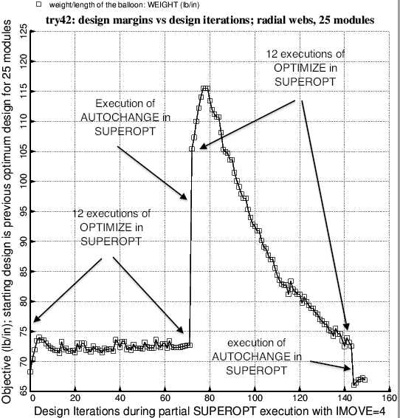

Fig. 34 Results of a SUPEROPT run with IMOVE = 4 and with the end user’s specification that there be 12 executions of OPTIMIZE for each execution of AUTOCHANGE in the “SUPEROPT” context. Note that with IMOVE = 4 many executions of OPTIMIZE are required for re-convergence to a local optimum design (see design iterations 73 – 143). Figure 27b, which was generated with IMOVE = 1, demonstrates that fewer executions of OPTIMIZE are require per execution of AUTOCHANGE for re-convergence to local optimum designs. This characteristic enables much more design space to be explored during an execution of SUPEROPT when IMOVE = 1 than is the case when IMOVE = 4. Ordinarily, SUPEROPT should be executed only with IMOVE = 1.