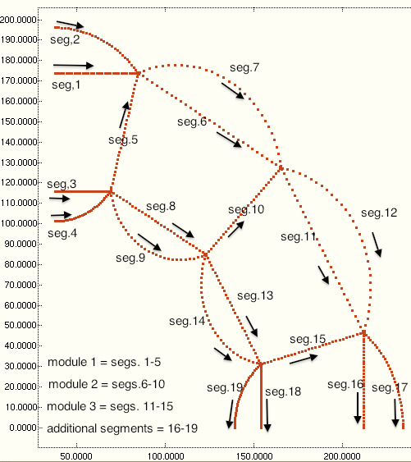

Fig. 4 The complex wall of the cylindrical vacuum chamber (balloon) consists of a number of modules, NMODUL. NMODUL is an input quantity that the end user chooses when executing the GENOPT processor, BEGIN. In this crude model of a balloon wall **with radial webs** NMODUL = 3. The “shell” segment numbering convention and the direction of “travel” along each segment in the BIGBOSOR4 model are displayed here. Each “shell” segment is discretized in the meridional coordinate: 31 nodal points per segment. Variation of the buckling modal displacements in the direction normal to the plane of the paper is trigonometric. Although the computer program, BIGBOSOR4, was created to analyze shells with finite bending stiffness and the segments of the vacuum chamber treated in this paper act more like membranes than like shells, useful predictions are obtained.