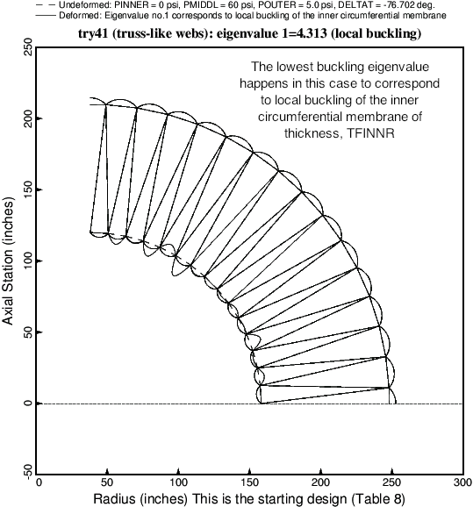

Fig. 6a The critical buckling mode of the starting design of the vacuum chamber with **truss-like (slanted) webs** and with NMODUL = 15 (15 modules). In every case explored in this paper the lowest **local** buckling eigenvalue (buckling load factor) corresponds to buckling (wrinkling) of the inner circumferential membrane with thickness, TFINNR. Sometimes, especially for the balloons with radial webs, the critical buckling mode (buckling mode associated with the lowest eigenvalue) corresponds to overall ovalization of the entire cross section of the balloon. See Fig. 23 for example. In all cases there are many, many local buckling eigenvalues clustered very closely. This clustering makes it difficult to find the eigenvalue associated with general buckling, unless that eigenvalue happens to be lower than the lowest local buckling eigenvalue. The starting design listed in Table 8 has HEIGHT = 90 inches, RINNER = 8 inches, ROUTER = 15 inches, and all five thicknesses, TINNER, TOUTER, TFINNR, TFOUTR, TFWEBS = 0.1 inch.