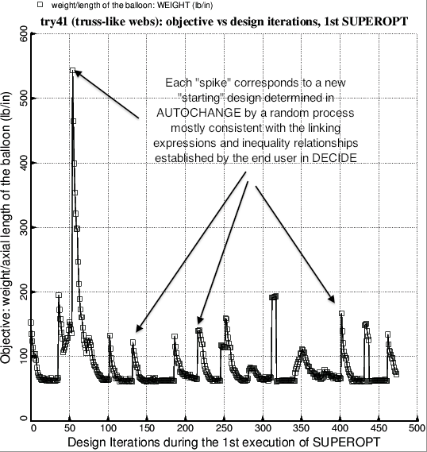

Fig. 6b Evolution of the objective (weight/axial length) during the first execution of the GENOPT processor called SUPEROPT. A successful and complete execution of SUPEROPT requires about 20 hours of computer time on the writer’s workstation for the balloon with 15 modules over 90 degrees of circumference (previous figure). In this first execution of SUPEROPT the two radii, RINNER and ROUTER (Fig. 1) are not decision variables (Table 9). The optimum design obtained after the first execution of SUPEROPT is listed in Table 11 and archived with the use of the GENOPT processor called CHANGE (Table 12).