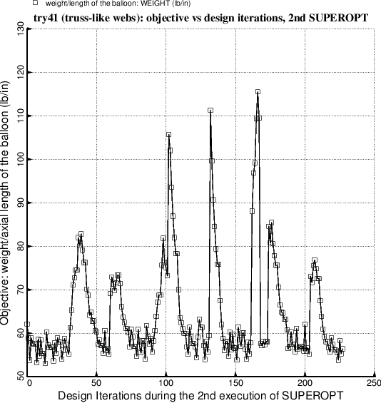

Fig. 7 Evolution of the objective (weight/axial length) during the second execution of the GENOPT processor, SUPEROPT. This 2nd execution of SUPEROPT was terminated on purpose because the writer did not want to wait for several hours for completion of the approximately 470 iterations specified by the GENOPT software. In this 2nd execution of SUPEROPT the two radii, RINNER and ROUTER (Fig. 1) are now decision variables (Table 13). The optimum design obtained after the second execution of SUPEROPT is listed in Table 14 and archived with the use of the GENOPT processor called CHANGE (Table 15).