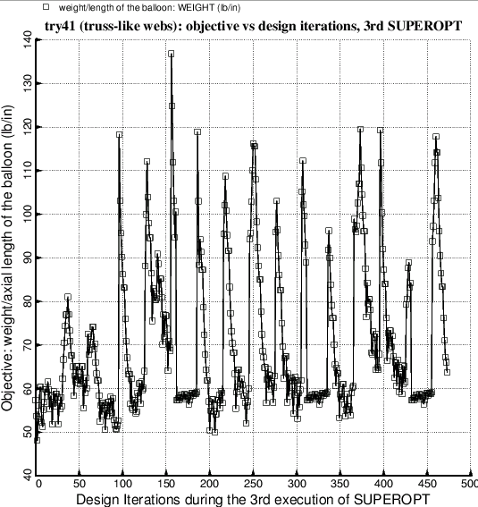

Fig. 8 Evolution of the objective (weight/axial length) during the third execution of the GENOPT processor, SUPEROPT. New lower bounds of the decision variables are specified in the execution of the GENOPT processor called DECIDE before the launch of this third execution of SUPEROPT (Table 16). The optimum design obtained after this third execution of SUPEROPT happens to be the same as that obtained after the second execution of SUPEROPT (Tables 14 and 15). Notice that starting at Design Iterations 155, 305, and 430 there is temporarily less jumpiness of the objective in successive design iterations. This happens because SUPEROPT temporarily resets the move limit of decision variables to a much more restrictive value in order to “close in” on a possibly better optimum design in the immediate neighborhood of whatever optimum has been determined up to that point in the long SUPEROPT process. In this particular case the exploration in the immediate neighborhood in design space did not result in a better optimum design.