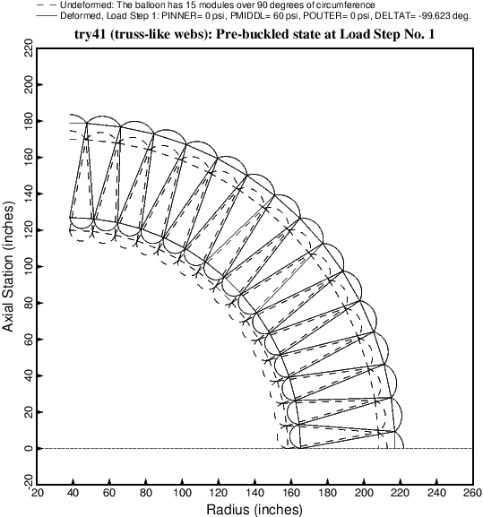

Fig. 9 Uniform pre-buckled state of the balloon with truss-like (slanted) webs subjected to the loads in Load Step No. 1, that is, before the outer pressure, POUTER = 15 psi, has been applied. As described in the text the delta-temperature, DELTAT = -99.623, is applied in order to generate the correct pre-buckling axial tension produced by PINNER because the ends of the cavity between the inner and outer walls is assumed to be sealed at the two ends of the cylindrical vacuum chamber. Note: plots of this type, generated via a BIGBOSOR4 input file called “try4.BEHX2”, can no longer be obtained without modifying SUBROUTINE BEHX2 as described in **Item 8** of **Section 8**.