FEDERAL STATE AUTONOMOUS EDUCATIONAL INSTITUTION

OF HIGHER EDUCATION

ITMO UNIVERSITY

Report

on the practical task No. 1

“Algorithms for unconstrained nonlinear optimization. Direct methods”

Performed by

*Konstantin Krechetov*

*Academic group: j4132c*

Accepted by

Dr Petr Chunaev

St. Petersburg

2020

**Goal**

*The use of direct methods (one-dimensional methods of exhaustive search, dichotomy, golden section search; multidimensional methods of exhaustive search, Gauss, Nelder-Mead) in the tasks of unconstrained nonlinear*

**Formulation of the problem**

*Considering few one-dimensional functions (some of them are convex). Necessary with given precision approximate these functions with simple methods. Besides, noisy linear function should be approximated with linear and rational functions using exhaustive search, Gauss and Nelder-Mead methods.*

**Brief theoretical part**

*There are some optimization methods that needs more iterations than others. For example, golden section method is improved dichotomy method. The exhaustive approach demands much more function calls to explore its values but sometimes it’s necessary to get imagination of function.*

*Dichotomy and golden section methods are good for convex functions. Otherwise, they may find* ***local*** *minimum.*

*For multidimensional problems Gauss method may fail in case when extremum lines are parallel to axes. Nelder-Mead method can’t guarantee finding* ***global*** *extremum as well.*

**Results**

*The figures of functions and solutions of different methods are demonstrated below. The bar plots show number of function calls for each optimization method.*

*Part 1.*

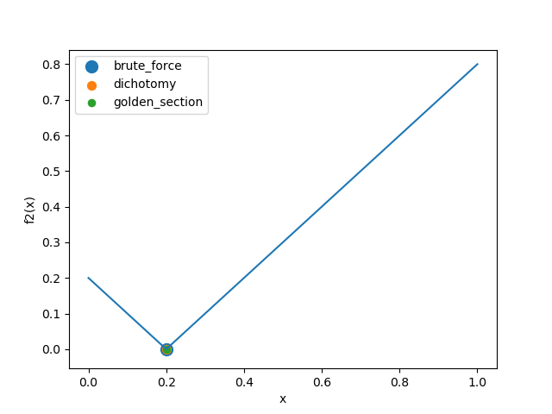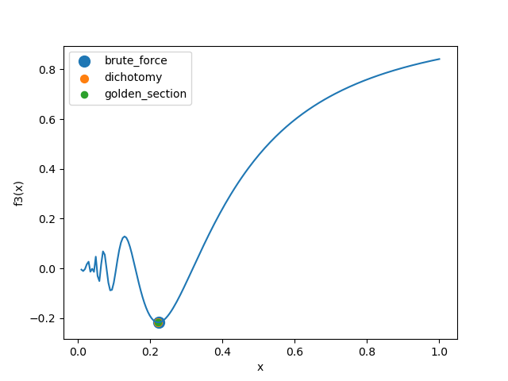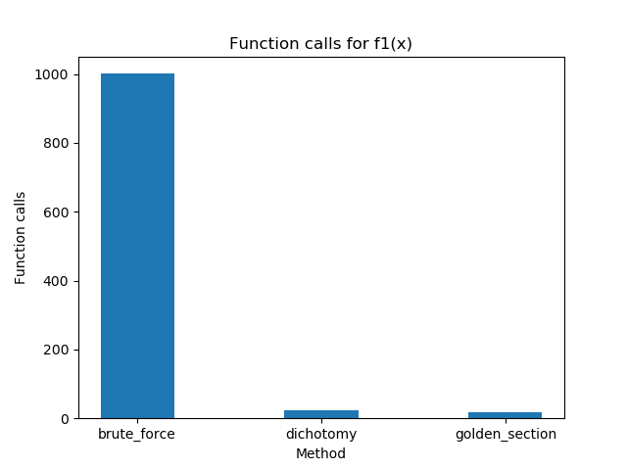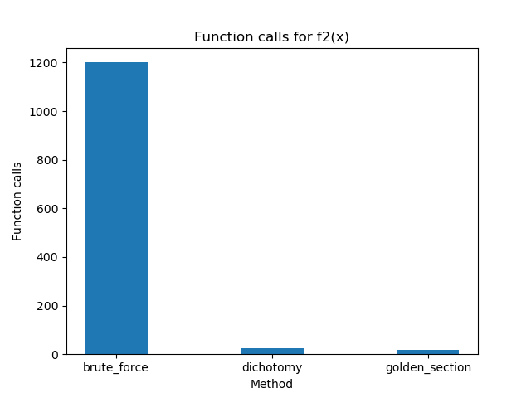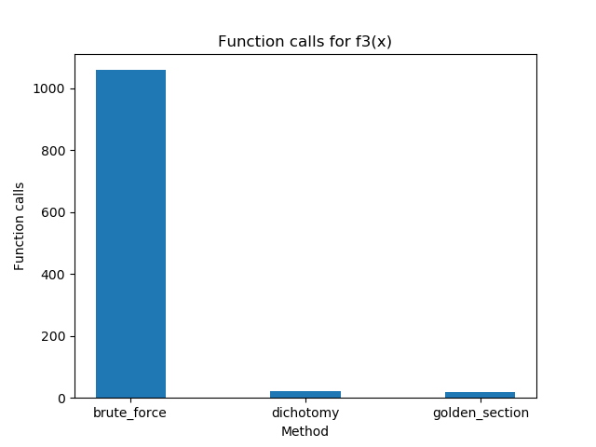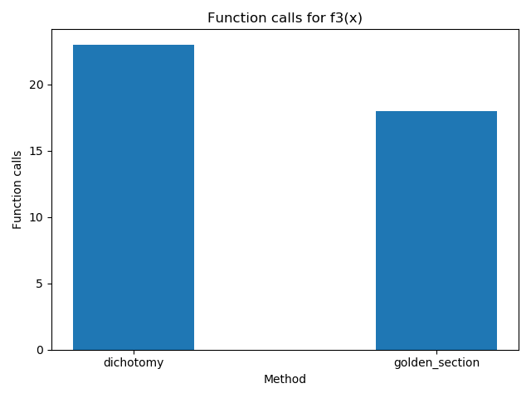

*Part 2.*

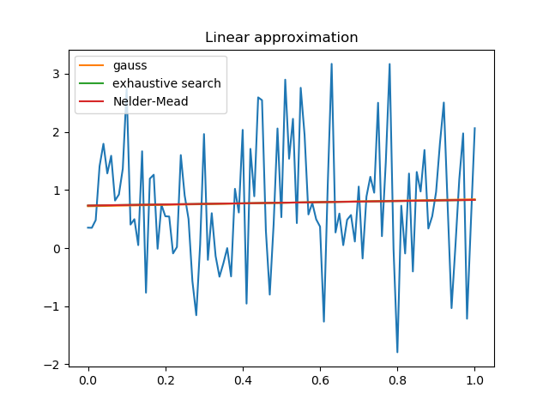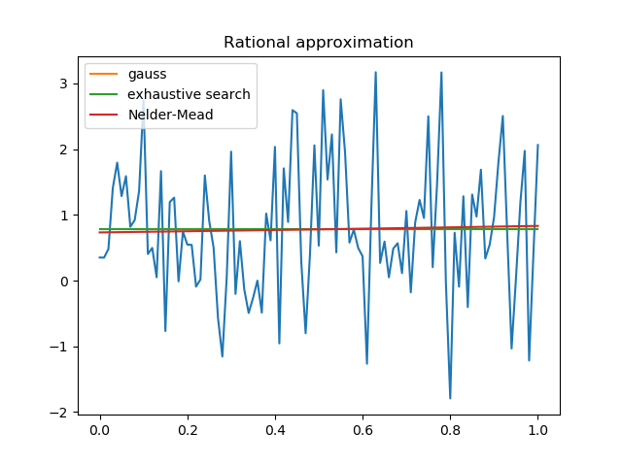

**Conclusions**

*Thus, we can see that exhaustive search is the slowest one but it gives appropriate solution. Golden section method needs less function calls that dichotomy one. All solutions are close to each other.*

**Appendix**

*Source code is available on*

<https://github.com/KostyaKrechetov/ITMO-Analysis-and-development-of-algorithms/tree/master/Task2>