FEDERAL STATE AUTONOMOUS EDUCATIONAL INSTITUTION

OF HIGHER EDUCATION

ITMO UNIVERSITY

Report

on the practical task No. 4

“Algorithms for unconstrained nonlinear optimization. Stochastic and metaheuristic algorithms”

Performed by

*Konstantin Krechetov*

*Academic group: j4132c*

Accepted by

Dr Petr Chunaev

St. Petersburg

2020

**Goal**

*The use of stochastic and metaheuristic algorithms (Simulated Annealing, Differential Evolution, Particle Swarm Optimization) in the tasks of unconstrained nonlinear optimization and the experimental comparison of them with Nelder-Mead and ﻿Levenberg-Marquardt algorithms*

**Formulation of the problem**

*Noisy discontinuous function should be approximated with rational function using stochastic and metaheuristic algorithms. Those results, number of iterations and precision must be compared and demonstrated.*

**Brief theoretical part**

*There are some stochastic and metaheuristic algorithms inspired by nature. Usually* ***they are good in global******optimization*** *but require adjusting hyper-parameters. What is more, such algorithms can process complex functions that has no opportunity to calculate first/second-order derivatives. Therefore, on average these methods take more time than others.*

*Particle Swarm Optimization (PSO) simulates swarm movement where each individual is affected by all others. It helps to get out of local extremum.*

*Simulated annealing is a metaheuristic algorithm that solves the optimization problem similar to the process of annealing in metallurgy. Step by step, it decreases “energy” of system. It uses Metropolis algorithm to choose new potential point where error function has less value.*

*Differential Evolution is simulation of actual Evolution. It bases on mutation, recombination, selection and other natural effects. This algorithm like PSO requires proper hyper-parameters setup to gain its best speed.*

**Results**

*The figures of functions and solutions by different methods are demonstrated below.*

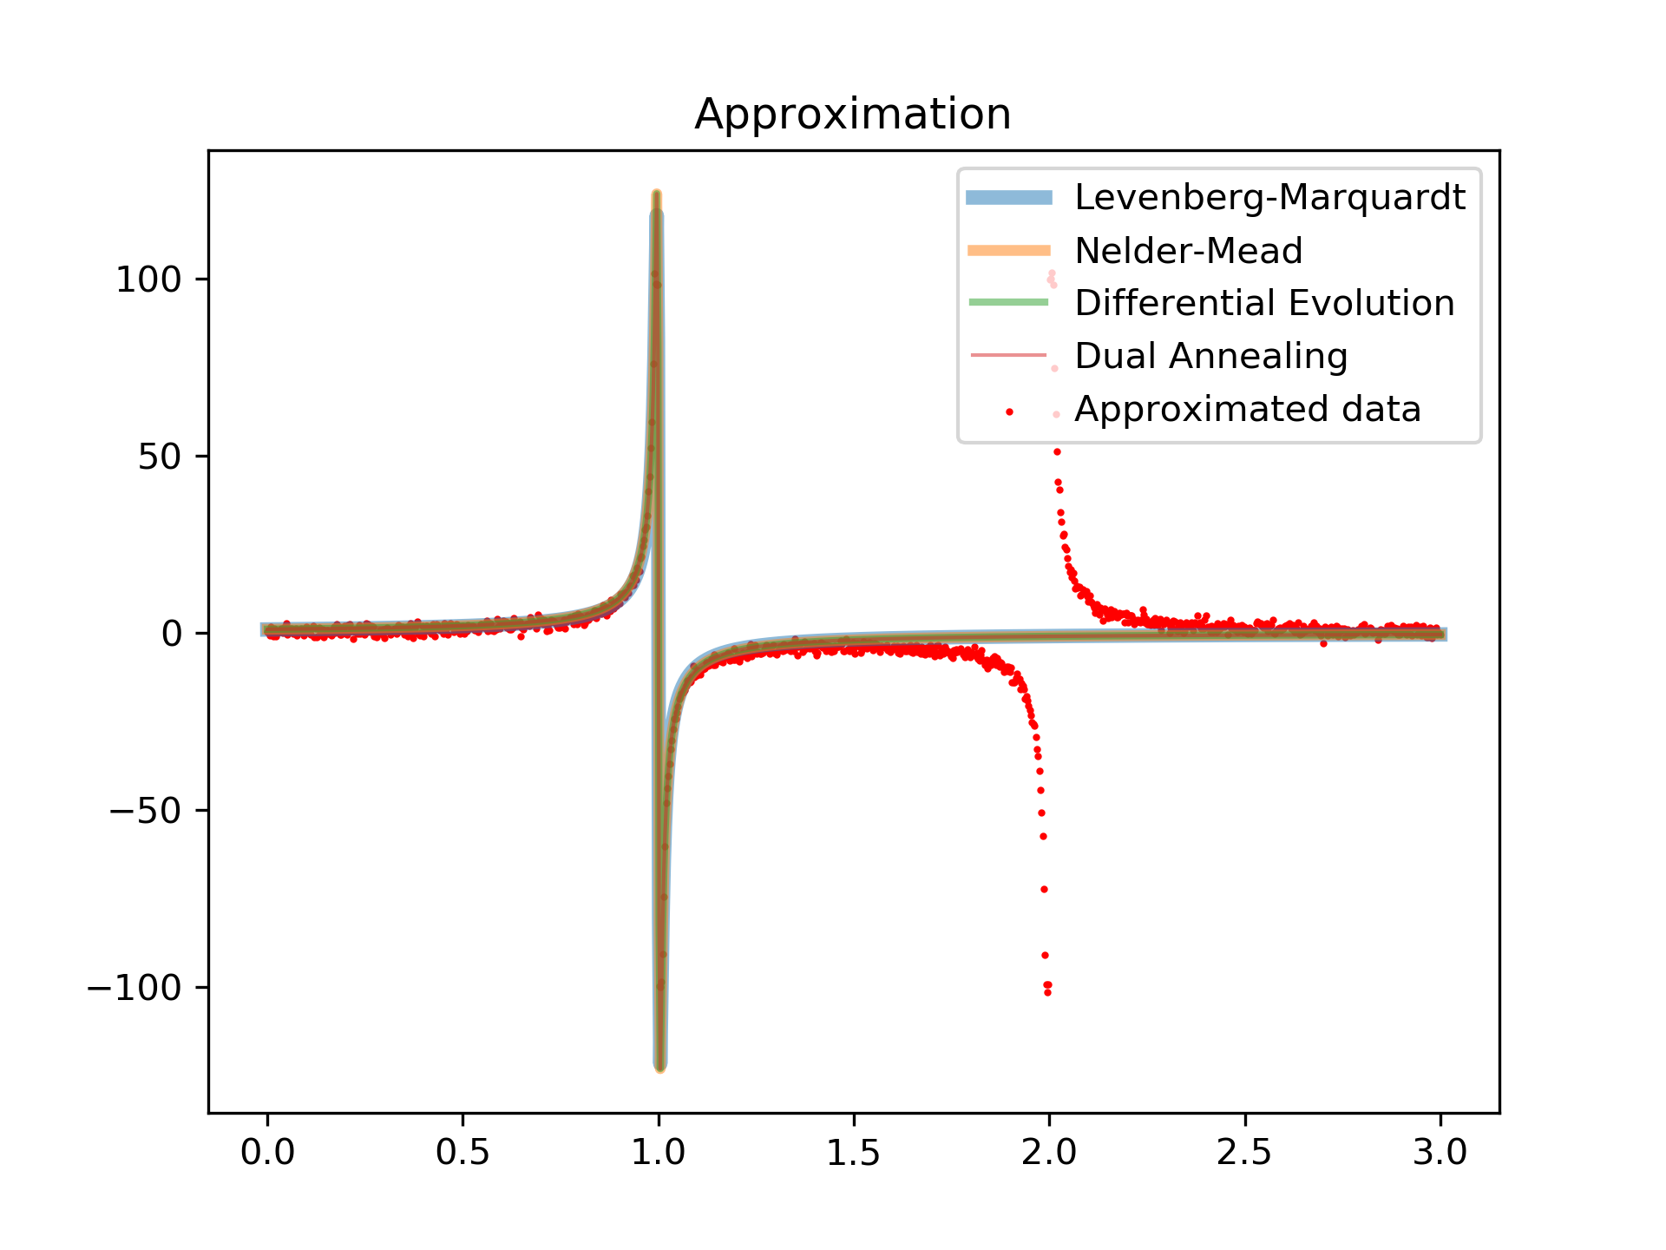

*Each algorithm found approximation but it still can’t describe the function gap at $x≈2$.*

*The error*

$$D\left(a,b,c,d\right)=\sum_{k=0}^{1000}{({F\left(x_{k},a,b,c,d\right)-y_{k})}^{2}}$$

*for each function is following:*

*Given function*

$$f\left(x\right)=\frac{1}{x^{2}-3x+2}$$

*without noise: 4050895702020913.0*

*Levenberg-Marquardt: 450396673.27523243*

*Nelder-Mead: 136561.6070635644*

*Differential Evolution:* *136561.6092571589*

*Dual Annealing:* *136561.61034193137*

*Number of function evaluations:*

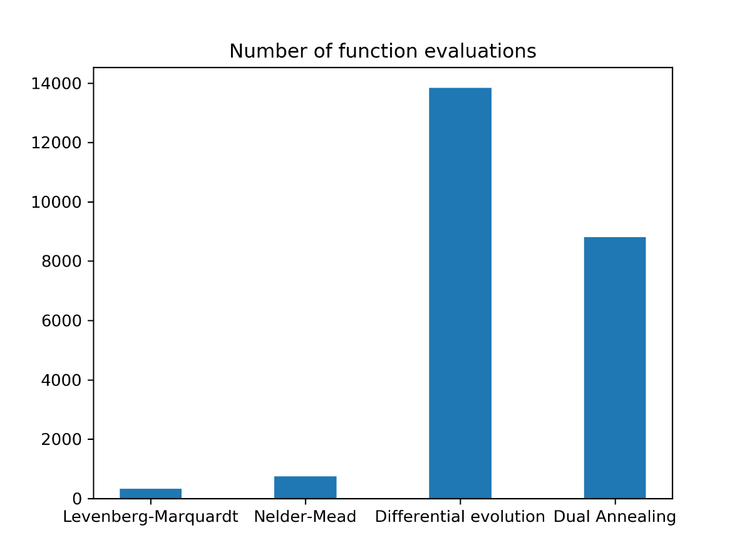

**Conclusions**

*All methods except Levenberg-Marquardt found extremum which might be very close to global one (in few executions). Levenberg-Marquardt sometimes finds local minimum and provides much worse solution than other algorithms.*

*Besides, there is a big difference in number of function evaluations. Stochastic and metaheuristic algorithms uses much more function calls but they are able to find global minimum. And Nelder-Mead and Levenberg-Marquardt methods, vice versa, takes less function calls but* ***don’t guarantee to find global optimum****.*

**Appendix**

*Source code is available on*

<https://github.com/KostyaKrechetov/ITMO-Analysis-and-development-of-algorithms/tree/master/Task4>