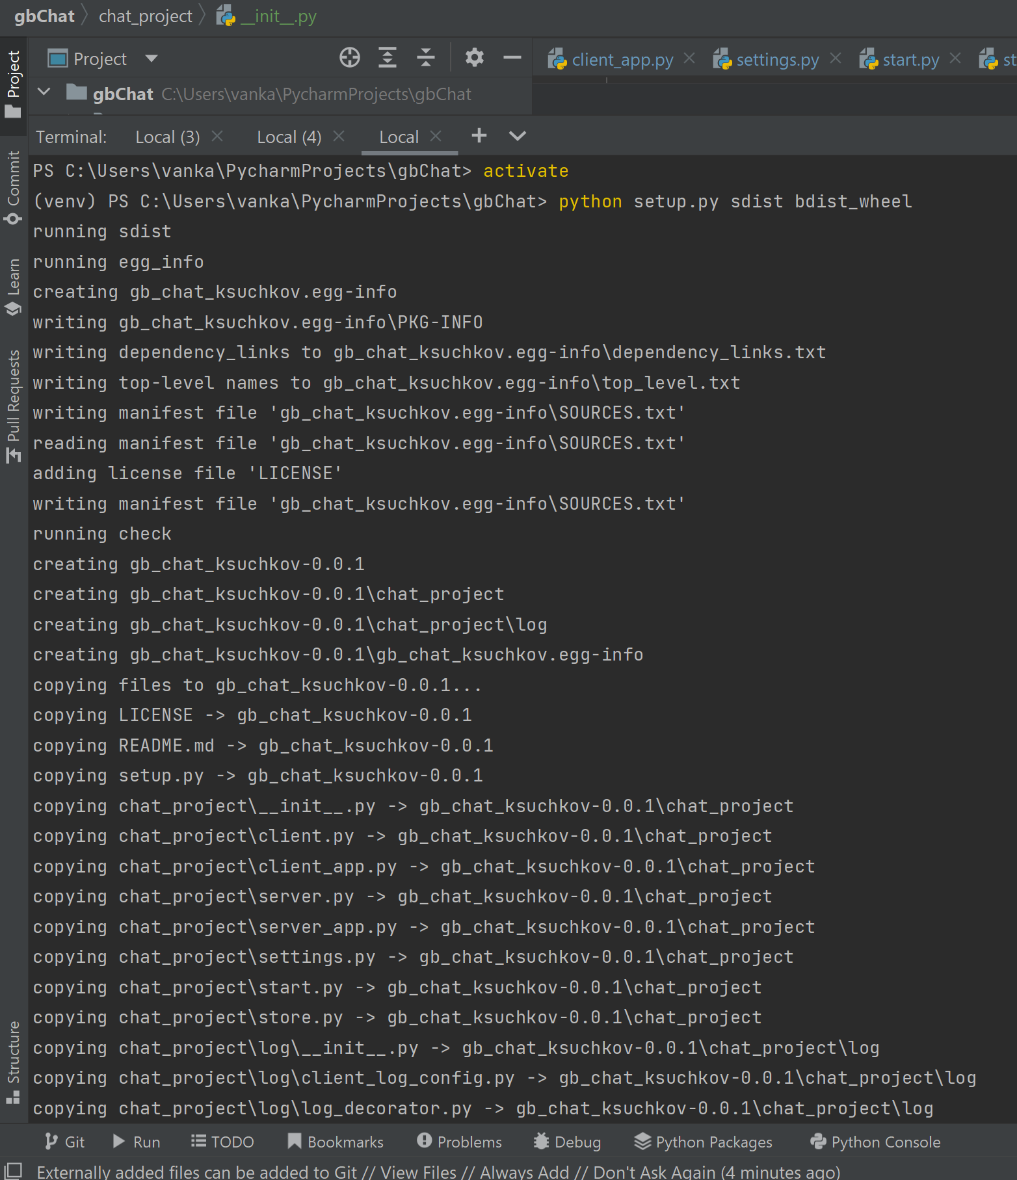

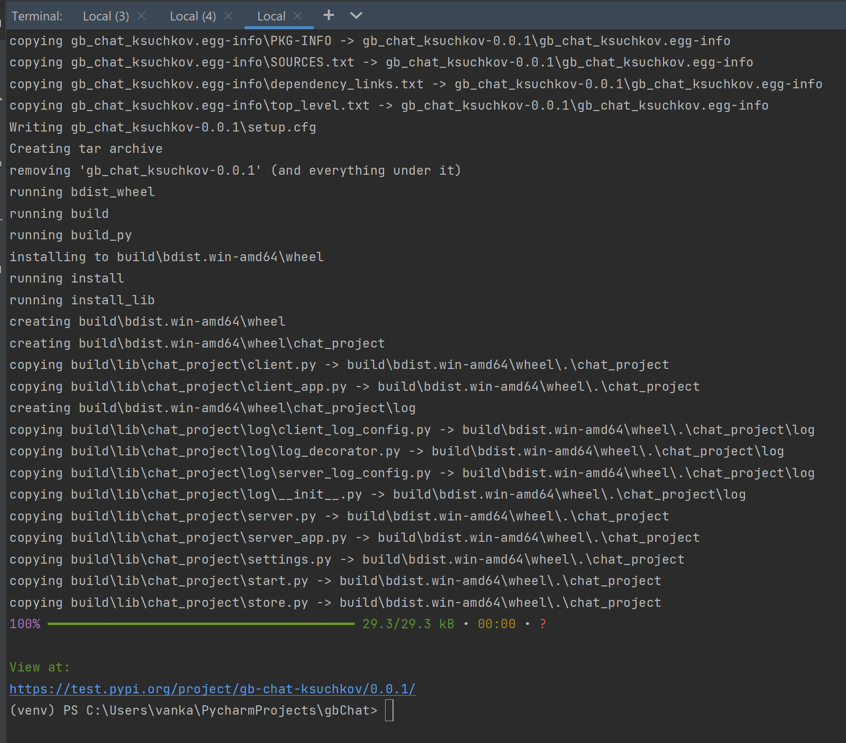

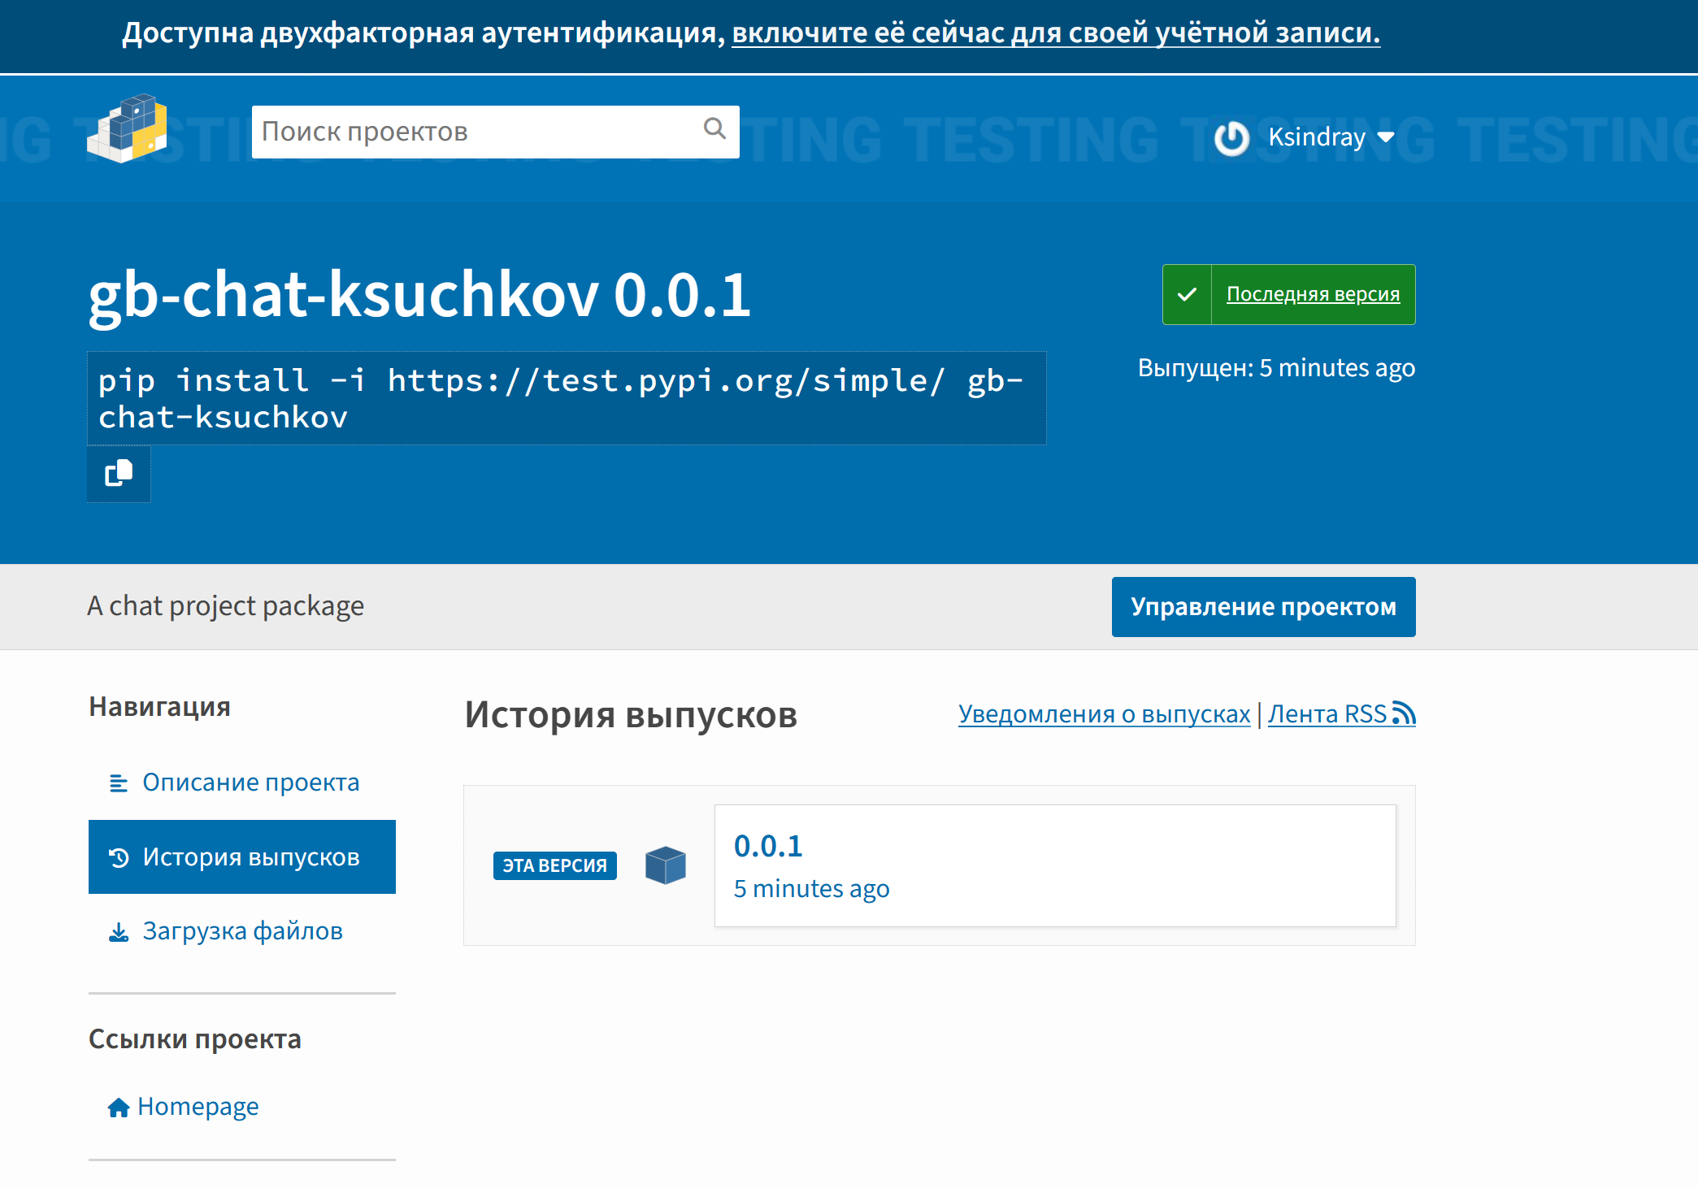

pip install -i https://test.pypi.org/simple/ gb-chat-ksuchkov

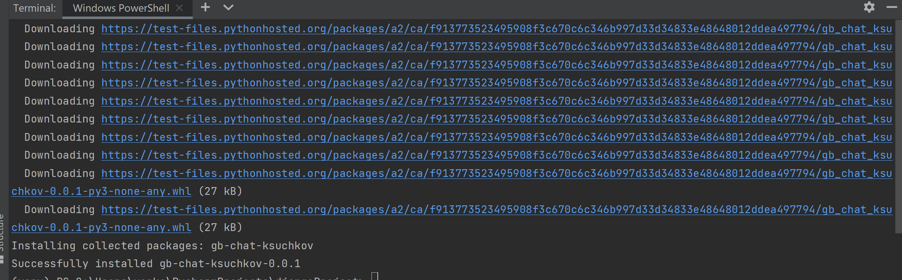

(venv) PS C:\Users\vanka\PycharmProjects\chat_lesson_16> pip install pysqlite3

Collecting pysqlite3

Using cached pysqlite3-0.5.0.tar.gz (40 kB)

Building wheels for collected packages: pysqlite3

Building wheel for pysqlite3 (setup.py) ... error

ERROR: Command errored out with exit status 1:

command: 'C:\Users\vanka\PycharmProjects\chat_lesson_16\venv\Scripts\python.exe' -u -c 'import io, os, sys, setuptools, tokenize; sys.

argv[0] = '"'"'C:\\Users\\vanka\\AppData\\Local\\Temp\\pip-install-22_l_zet\\pysqlite3_56fa4b6997ab4e4da0211633148a4bf4\\setup.py'"'"'; _

_file__='"'"'C:\\Users\\vanka\\AppData\\Local\\Temp\\pip-install-22_l_zet\\pysqlite3_56fa4b6997ab4e4da0211633148a4bf4\\setup.py'"'"';f =

getattr(tokenize, '"'"'open'"'"', open)(__file__) if os.path.exists(__file__) else io.StringIO('"'"'from setuptools import setup; setup()

'"'"');code = f.read().replace('"'"'\r\n'"'"', '"'"'\n'"'"');f.close();exec(compile(code, __file__, '"'"'exec'"'"'))' bdist_wheel -d 'C:\Users\vanka\AppData\Local\Temp\pip-wheel-0mqgvn7u'

cwd: C:\Users\vanka\AppData\Local\Temp\pip-install-22_l_zet\pysqlite3_56fa4b6997ab4e4da0211633148a4bf4\

Complete output (18 lines):

running bdist_wheel

running build

running build_py

creating build

creating build\lib.win-amd64-cpython-37

creating build\lib.win-amd64-cpython-37\pysqlite3

copying pysqlite3\dbapi2.py -> build\lib.win-amd64-cpython-37\pysqlite3

copying pysqlite3\__init__.py -> build\lib.win-amd64-cpython-37\pysqlite3

running build_ext

Builds a C extension linking against libsqlite3 library

building 'pysqlite3._sqlite3' extension

creating build\temp.win-amd64-cpython-37

creating build\temp.win-amd64-cpython-37\Release

creating build\temp.win-amd64-cpython-37\Release\src

"C:\Program Files (x86)\Microsoft Visual Studio\2022\BuildTools\VC\Tools\MSVC\14.33.31629\bin\HostX86\x64\cl.exe" /c /nologo /O2 /W3 /G

L /DNDEBUG /MD -DMODULE_NAME=\\\"pysqlite3.dbapi2\\\" -I/usr/include -IC:\Users\vanka\PycharmProjects\chat_lesson_16\venv\include -IC:\Us

ers\vanka\AppData\Local\Programs\Python\Python37\include -IC:\Users\vanka\AppData\Local\Programs\Python\Python37\Include "-IC:\Program Fi

les (x86)\Microsoft Visual Studio\2022\BuildTools\VC\Tools\MSVC\14.33.31629\include" "-IC:\Program Files (x86)\Microsoft Visual Studio\20

22\BuildTools\VC\Auxiliary\VS\include" "-IC:\Program Files (x86)\Windows Kits\10\include\10.0.19041.0\ucrt" "-IC:\Program Files (x86)\Win

dows Kits\10\\include\10.0.19041.0\\um" "-IC:\Program Files (x86)\Windows Kits\10\\include\10.0.19041.0\\shared" "-IC:\Program Files (x86

)\Windows Kits\10\\include\10.0.19041.0\\winrt" "-IC:\Program Files (x86)\Windows Kits\10\\include\10.0.19041.0\\cppwinrt" /Tcsrc\blob.c /Fobuild\temp.win-amd64-cpython-37\Release\src\blob.obj

blob.c

C:\Users\vanka\AppData\Local\Temp\pip-install-22_l_zet\pysqlite3_56fa4b6997ab4e4da0211633148a4bf4\src\blob.h(4): fatal error C1083: ЌҐ г¤ Ґвбп ®вЄалвм д ©« ўЄ«озҐ­ЁҐ: sqlite3.h: No such file or directory,

error: command 'C:\\Program Files (x86)\\Microsoft Visual Studio\\2022\\BuildTools\\VC\\Tools\\MSVC\\14.33.31629\\bin\\HostX86\\x64\\cl.exe' failed with exit code 2

----------------------------------------

ERROR: Failed building wheel for pysqlite3

Running setup.py clean for pysqlite3

Failed to build pysqlite3

Installing collected packages: pysqlite3

Running setup.py install for pysqlite3 ... error

ERROR: Command errored out with exit status 1:

command: 'C:\Users\vanka\PycharmProjects\chat_lesson_16\venv\Scripts\python.exe' -u -c 'import io, os, sys, setuptools, tokenize; sy

s.argv[0] = '"'"'C:\\Users\\vanka\\AppData\\Local\\Temp\\pip-install-22_l_zet\\pysqlite3_56fa4b6997ab4e4da0211633148a4bf4\\setup.py'"'"';

__file__='"'"'C:\\Users\\vanka\\AppData\\Local\\Temp\\pip-install-22_l_zet\\pysqlite3_56fa4b6997ab4e4da0211633148a4bf4\\setup.py'"'"';f

= getattr(tokenize, '"'"'open'"'"', open)(__file__) if os.path.exists(__file__) else io.StringIO('"'"'from setuptools import setup; setup

()'"'"');code = f.read().replace('"'"'\r\n'"'"', '"'"'\n'"'"');f.close();exec(compile(code, __file__, '"'"'exec'"'"'))' install --record

'C:\Users\vanka\AppData\Local\Temp\pip-record-mqhtnyqr\install-record.txt' --single-version-externally-managed --compile --install-headers 'C:\Users\vanka\PycharmProjects\chat_lesson_16\venv\include\site\python3.7\pysqlite3'

cwd: C:\Users\vanka\AppData\Local\Temp\pip-install-22_l_zet\pysqlite3_56fa4b6997ab4e4da0211633148a4bf4\

Complete output (31 lines):

running install

C:\Users\vanka\PycharmProjects\chat_lesson_16\venv\lib\site-packages\setuptools\_distutils\cmd.py:66: SetuptoolsDeprecationWarning: setup.py install is deprecated.

!!

********************************************************************************

Please avoid running ``setup.py`` directly.

Instead, use pypa/build, pypa/installer, pypa/build or

other standards-based tools.

See https://blog.ganssle.io/articles/2021/10/setup-py-deprecated.html for details.

********************************************************************************

!!

self.initialize_options()

running build

running build_py

creating build

creating build\lib.win-amd64-cpython-37

creating build\lib.win-amd64-cpython-37\pysqlite3

copying pysqlite3\dbapi2.py -> build\lib.win-amd64-cpython-37\pysqlite3

copying pysqlite3\__init__.py -> build\lib.win-amd64-cpython-37\pysqlite3

running build_ext

Builds a C extension linking against libsqlite3 library

building 'pysqlite3._sqlite3' extension

creating build\temp.win-amd64-cpython-37

creating build\temp.win-amd64-cpython-37\Release

creating build\temp.win-amd64-cpython-37\Release\src

"C:\Program Files (x86)\Microsoft Visual Studio\2022\BuildTools\VC\Tools\MSVC\14.33.31629\bin\HostX86\x64\cl.exe" /c /nologo /O2 /W3

/GL /DNDEBUG /MD -DMODULE_NAME=\\\"pysqlite3.dbapi2\\\" -I/usr/include -IC:\Users\vanka\PycharmProjects\chat_lesson_16\venv\include -IC:\

da0211633148a4bf4\\setup.py'"'"'; __file__='"'"'C:\\Users\\vanka\\AppData\\Local\\Temp\\pip-install-22_l_zet\\pysqlite3_56fa4b6997ab4e4da0211633148a4bf4\\setup.py'"'"';f = getattr(tokenize, '"'"'open'"'"', open)(__file__) if os.path.exists(__file__) else io.StringIO('"'"'from setuptools import setup; setup()'"'"');code = f.read().replace('"'"'\r\n'"'"', '"'"'\n'"'"');f.close();exec(compile(code, __file__, '"'"'exec'"'"'))' install --record 'C:\Users\vanka\AppData\Local\Temp\pip-record-mqhtnyqr\install-record.txt' --single-version-externally-managed --compile --install-headers 'C:\Users\vanka\PycharmProjects\chat_lesson_16\venv\include\site\python3.7\pysqlite3' Check the logs for full command output.

WARNING: You are using pip version 21.1.2; however, version 23.1.2 is available.

You should consider upgrading via the 'C:\Users\vanka\PycharmProjects\chat_lesson_16\venv\Scripts\python.exe -m pip install --upgrade pip' command.

(venv) PS C:\Users\vanka\PycharmProjects\chat_lesson_16> pip install pysqlite3

2. cx-freeze

