Basic map concepts

There are 2 players on the map with 2 bases. There are 2 crossing roads between these bases. Also, there are 5 villages.

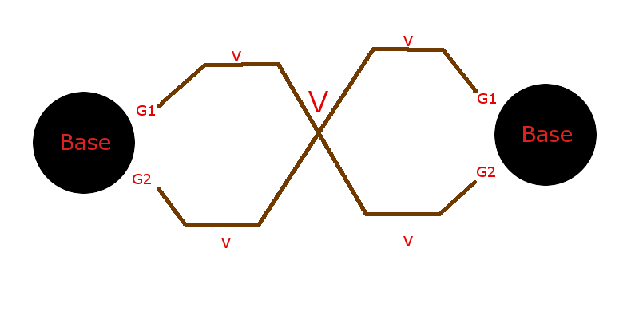

Gi are gates, V are villages. Each village gives 1000 money per second. Each player can hire warriors on base and send this warriors through gates. Warriors will move strictly on gate road. To win, one player must destroy one of another players’ gates.

Demo warriors

