**Answers 02 – OOD UML and Kanban board**

Produce a class diagram to model an online shopping website to represent a scenario when an order is processed

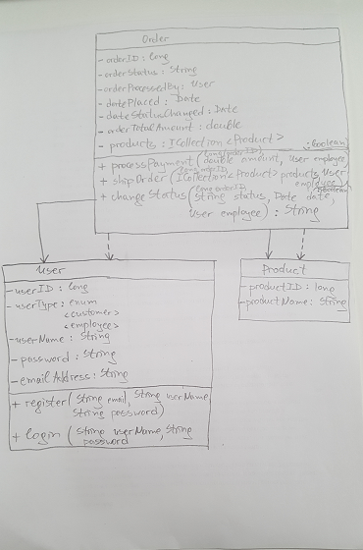

Produce a sequence diagram to model an online shopping website to represent a scenario when an order is processed

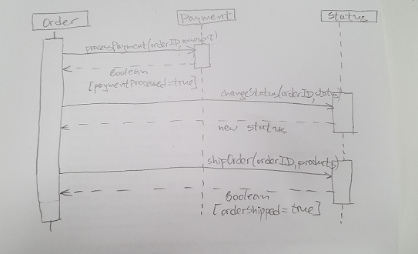

* What is UML?

The Unified Modelling Language (UML) is a general-purpose, developmental, modelling language in the field of software engineering, which is intended to provide a standard way to visualize the design of a system.

It is used for:

Object Oriented Design

Data structure modelling

Scenario modelling

Logical flow modelling

* What are the two categories of diagrams?

Structural - the structure/components/architecture of a system or process

Behavioural - the behaviour/functionality/operation of/changes to a system over time.

* What is a Use Case diagram?

A Behavioural diagram

High level view, from the perspective of outside the system

Models interaction between things external to the system (actors) and functionality within the system (use cases)

* What is a class diagram?

Class Diagram is the main building block of object-oriented modelling.

It is used for general conceptual modelling of the systematics of the application, and for detailed modelling translating the models into programming code.

A Structural diagram

Models the classes within an OOP program, including:

Their attributes and behaviours

Their relationships with other classes

Arrows model relationships, not flow

* What are the different forms of dependency in a class diagram?

