1. Download zip file and extract it as StorageManagement
2. Open it using intellij
3. Find pom.xml file open it and change this two numbers with JDK version that you have:  
   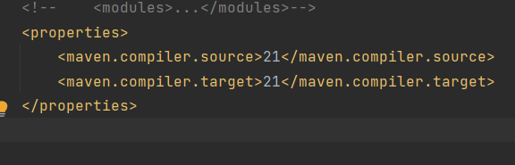
4. Then open neo4j desktop application create new project.
5. Then go to intellij and copy absolute path of project main file where neo4j.dump file is located, in this case name is StorageManagement.
6. Return in neo4j desktop and do the following: 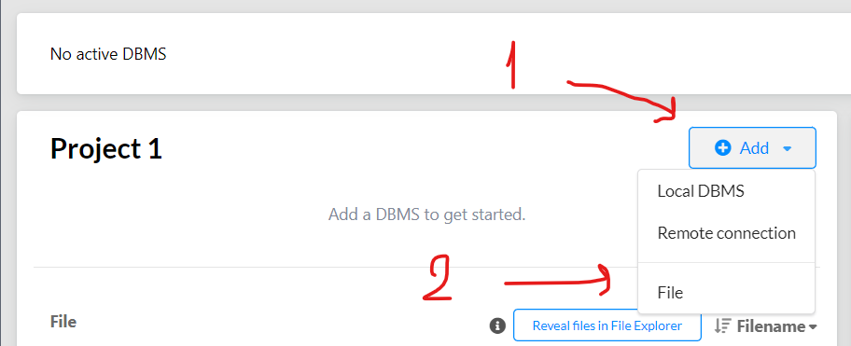
7. This window will pop up paste there the copied path and hit Enter.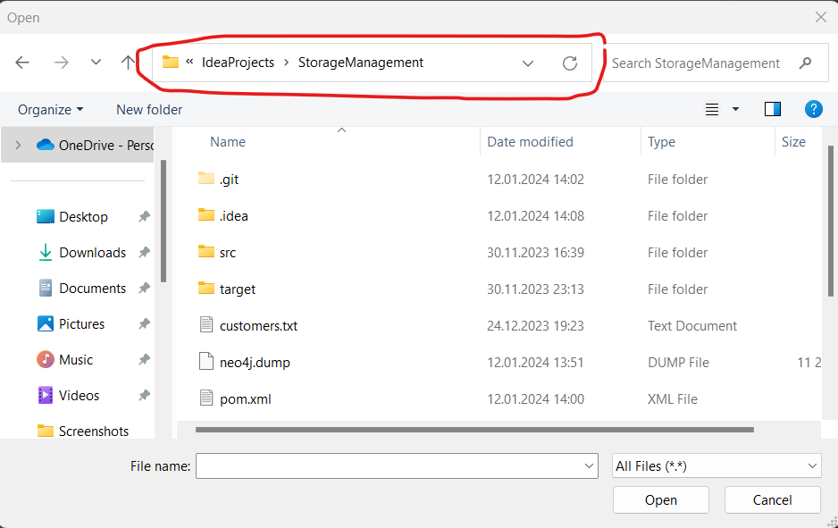
8. Then click neo4j.dump file and open. 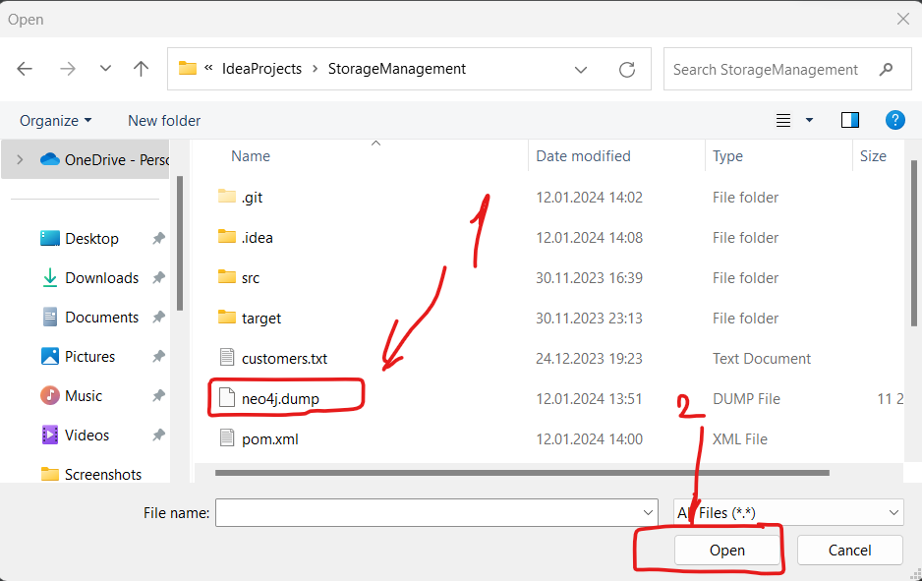
9. Then click three dots alongside the opened neo4j.dump file and then click ‘create new DBMS from dump’. 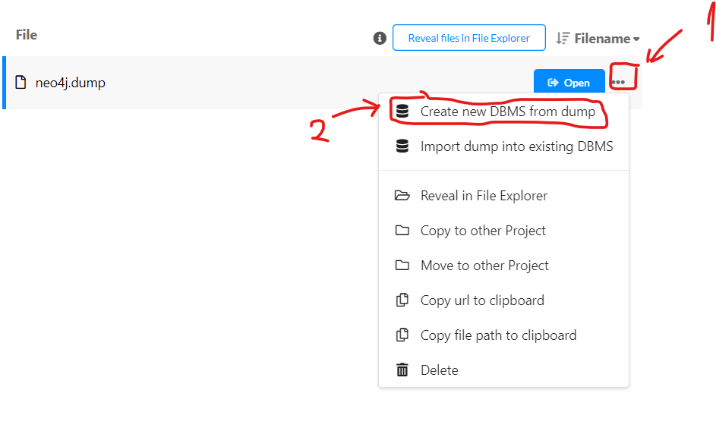
10. Then create the database with the desired passwrod.
11. Then click this two buttons. 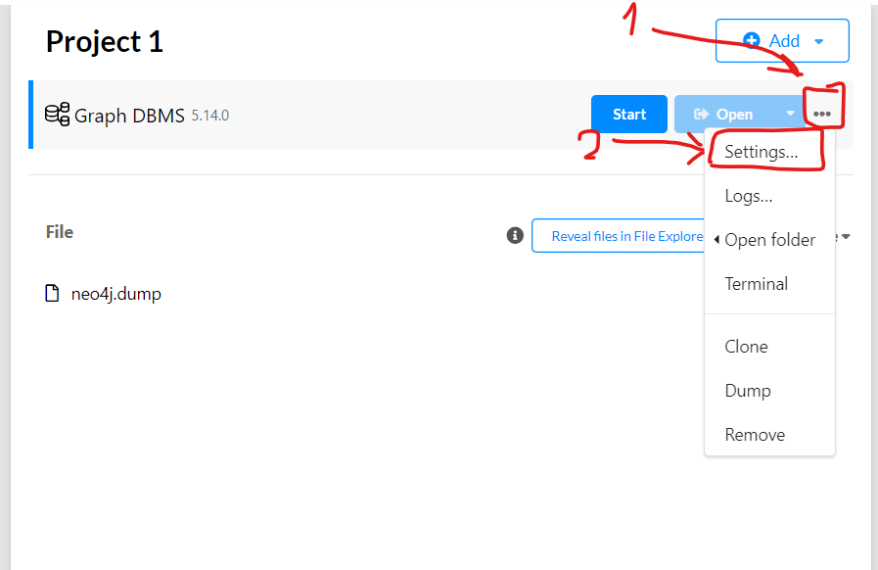
12. Then using ctrl+f search this term and change its value to false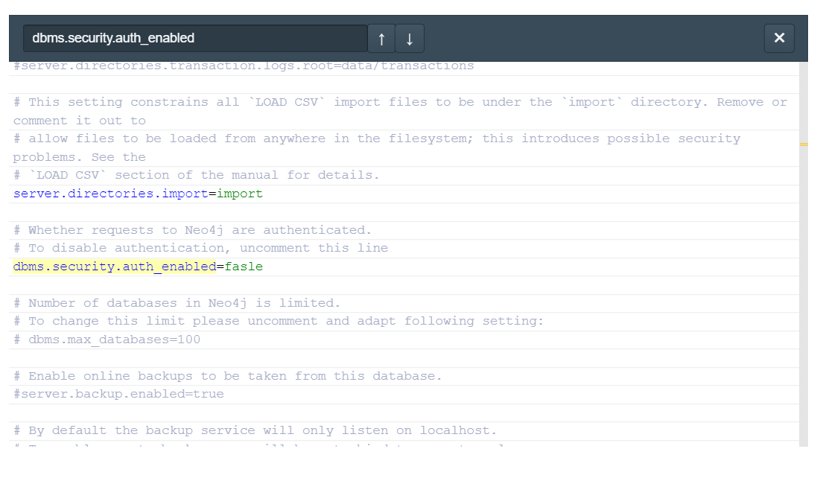
13. Then press apply and close.
14. Start the DBMS.
15. Press continue anyway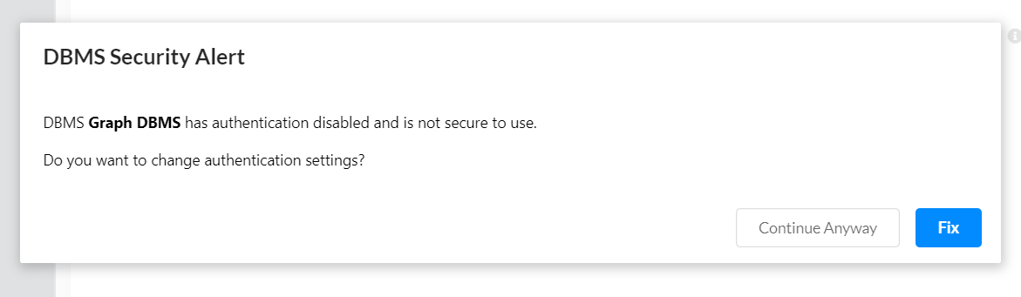
16. Now in intellij go ahead and find this class ‘src/main/java/org/example/views/MainWindow.java’ and run it.