CVEditor
Release Report
Group ID: 46

Ilias Kleftakis (2461)
Konstantinos Panagiotis Nakas (2501)

Versions History
Date | Version | Description | Author
27/03/2017 | 1.0 | First version. | Ilias Kleftakis,  Konstantinos Panagiotis Nakas
03/05/2017 | 2.0 | Second version. | Ilias Kleftakis,  Konstantinos Panagiotis Nakas

Introduction
This document provides information concerning the first release of the project.

Purpose
The preparation of a Curriculum Vitae (a.k.a. resume) is a very important task for everyone who is looking for a job or an internship. The main goal of the project is to develop CVEditor, an application that makes this task easier, especially for young inexperienced people such as graduate and undergraduate students. At a glance, CVEditor shall allow a user to prepare a new CV based on well known templates (chronological, functional, combination), change the structure of an existing CV by switching between these templates, generate actual CV documents in well known formats (Latex, Microsoft Word), trace changes between different CV versions and so on.

Document Structure
The rest of this document is structured as follows. Section 2 specifies the acceptance tests that have been employed for this release of the project. Section 3 specifies the main design concepts for this release of the project.

Acceptance Tests

Tests for User Story 1
Test ID | 1
Class | CVFactory
Test Name | CVFactoryTest
Description | When no type is given then exception is thrown
Test Data | null
Expected result | Null PointerException

Test ID | 2
Class | CVFactory
Test Name | CVFactoryTest
Description | When chronological type is given then chronological CV Is created
Test Data | Create a new chronological CV
Expected result | ChronologicalCV.class

Test ID | 3
Class | CVFactory
Test Name | CVFactoryTest
Description | When functional type is given then chronological CV Is created
Test Data | Create a new functional CV
Expected result | FunctionalCV

Test ID | 4
Class | CVFactory
Test Name | CVFactoryTest
Description | When combined type is given then chronological CV Is created
Test Data | Create a new combined CV
Expected result | CombinedCV

Tests for User Story 2
Test ID | 5
Class | ListSection
Test Name | ListSectionTest
Description | Test adding an item
Test Data | List item
Expected result | List size is 1

Test ID | 6
Class | ListSection
Test Name | ListSectionTest
Description | Test removing an item
Test Data | List item
Expected result | List size is 0

Test ID | 7
Class | CareerSummarySectionitem
Test Name | CareerSummarySectionitemTest
Description | When one item no error
Test Data | Date1 = 2017
Expected result | HasError() == false

Test ID | 8
Class | CareerSummarySectionitem
Test Name | CareerSummarySectionitemTest
Description | When dates in right order then no error
Test Data | Date1 = 2017  Date2 = 2016
Expected result | HasError() == false

Test ID | 9
Class | CareerSummarySectionitem
Test Name | CareerSummarySectionitemTest
Description | When dates in wrong order then error
Test Data | Date2 = 2017  Date1 = 2016
Expected result | HasError() == true  error description: Some dates are wrong. Please fix their order.

Test ID | 10
Class | EducationSectionItem
Test Name | EducationSectionitemTest
Description | When one item no error
Test Data | Date1 = 2017
Expected result | HasError() == false

Test ID | 11
Class | EducationSectionItem
Test Name | EducationSectionitemTest
Description | When dates in right order then no error
Test Data | Date1 = 2017  Date2 = 2016
Expected result | HasError() == false

Test ID | 12
Class | EducationSectionItem
Test Name | EducationSectionitemTest
Description | When dates in wrong order then error
Test Data | Date2 = 2017  Date1 = 2016
Expected result | HasError() == true  error description: Some dates are wrong. Please fix their order.

Test ID | 13
Class | ProfessionalExperienceSectionItem
Test Name | ProfessionalExperienceSectionitemTest
Description | When one item no error
Test Data | Date1 = 2017
Expected result | HasError() == false

Test ID | 14
Class | ProfessionalExperienceSectionItem
Test Name | ProfessionalExperienceSectionitemTest
Description | When dates in right order then no error
Test Data | Date1 = 2017  Date2 = 2016
Expected result | HasError() == false

Test ID | 15
Class | ProfessionalExperienceSectionItem
Test Name | ProfessionalExperienceSectionitemTest
Description | When dates in wrong order then error
Test Data | Date2 = 2017  Date1 = 2016
Expected result | HasError() == true  error description: Some dates are wrong. Please fix their order.

Test ID | 16
Class | ProfessionalExperienceSectionItem
Test Name | ProfessionalExperienceSectionitemTest
Description | When end date smaller than start date then error
Test Data | startDate = 2013  endDate = 2016
Expected result | HasError() == true  Start and end date are in wrong order: 2016, 2013

Tests for User Story 3
Test ID | 17
Class | WriterFactory
Test Name | WriterFactory Test
Description | When .txt file is given then Text File Writer is created.
Test Data | New File(“filename.txt”)
Expected result | TextWriter object is created

Test ID | 18
Class | WriterFactory
Test Name | WriterFactory Test
Description | When .tex file is given then Latex File Writer is created.
Test Data | New File(“filename.tex”)
Expected result | LatexWriter object is created.

Test ID | 19
Class | WriterFactory
Test Name | WriterFactory Test
Description | When illegal file is given then exception is thrown.
Test Data | New File(“filename.doc”)
Expected result | IllegalArgumentException is thrown.

Tests for User Story 4
Test ID | 20
Class | ReaderFactory
Test Name | ReaderFactory test
Description | When .txt file is given then Text File Reader is created.
Test Data | New File(“filename.txt”)
Expected result | TextReader object is created.

Test ID | 21
Class | ReaderFactory
Test Name | ReaderFactory test
Description | When .tex file is given then Latex File Reader is created.
Test Data | New File(“filename.tex”)
Expected result | LatexReader object is created.

Test ID | 22
Class | ReaderFactory
Test Name | ReaderFactory test
Description | When illegal file is given then exception is thrown.
Test Data | New File(“filename.doc”)
Expected result | IllegalArgumentException is thrown.

Tests for User Story 5
Test ID | 23
Class | CVSelectorController
Test Name | CVSelectorController test
Description | When CVs have different types then exception is thrown.
Test Data | New ChronologicalCV  New FunctionalCV
Expected result | IllegalArgumentException is thrown.

Test ID | 24
Class | CVSelectorController
Test Name | CVSelectorController test
Description | When CVs have different names then exception is thrown.
Test Data | New ChronologicalCV with author name “Foo”  New FunctionalCV with author name “Bar”
Expected result | IllegalArgumentException is thrown.

Design

Architecture
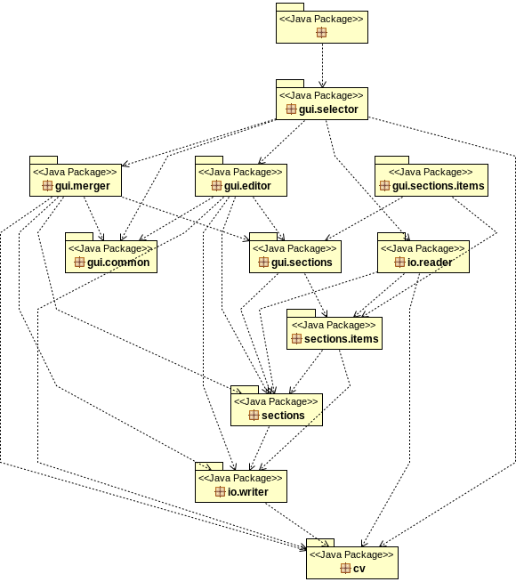

Default Package
Default package contains just the main class.
Class Name: Main
Responsibilities:  - Displays the first window | Collaborations:  - CVSelectorGUI

CV
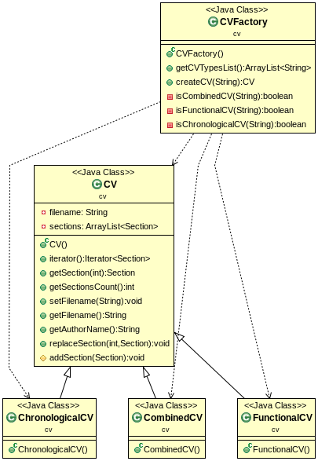
Classes in this package are responsible for managing the CV document.
Class Name: CV
Responsibilities:  - Store the sections of the CV  - Add/remove sections from the CV | Collaborations:  - Section  - GeneralInformationSection

Class Name: ChronologicalCV
Responsibilities:  - Stores the sections of a chronological CV | Collaborations:  - CV  - ListSection  - ParagraphSection

Class Name: FunctionalCV
Responsibilities:  - Stores the sections of a functional CV | Collaborations:  - CV  - ListSection  - ParagraphSection

Class Name: CombinedCV
Responsibilities:  - Stores the sections of a combined CV | Collaborations:  - CV  - ListSection  - ParagraphSection

Class Name: CVFactory
Responsibilities:  - Creates the appropriate CV | Collaborations:  - CV  - FunctionalCV  - ChronologicalCV  - CombinedCV

GUI Editor
Classes in this package are responsible for the main application window.
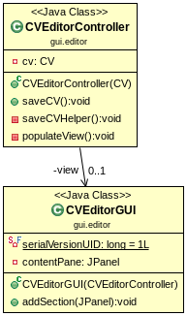
Class Name: CVEditorGUI
Responsibilities:  - Create the main window | Collaborations:

Class Name: CVEditorController
Responsibilities:  - Populate the main application window with the appropriate section items | Collaborations:  - CVEditorGUI  - CV  - SectionFactory  - Section

GUI Sections
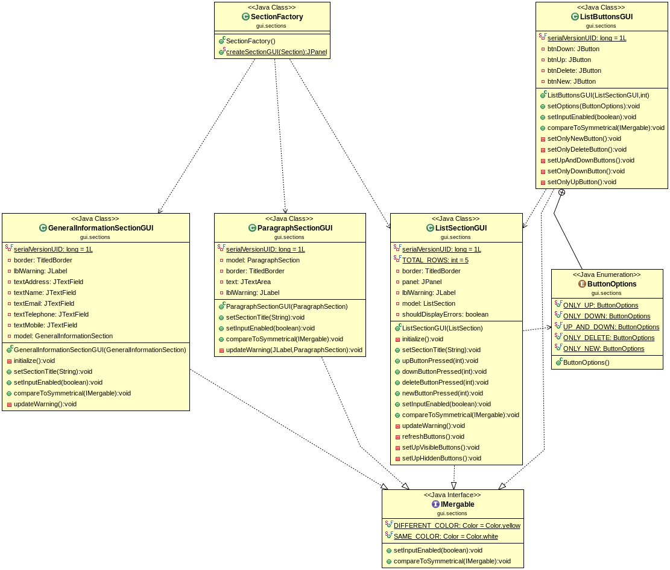
Classes in this package are responsible for the graphical representation of the CV sections.

Class Name: GeneralInformationSectionGUI
Responsibilities:  - Display general information section of the CV  - Update the back-end item based on user input | Collaborations:  - GeneralInformationSection

Class Name: ParagraphSectionGUI
Responsibilities:  - Display a paragraph section of the CV  - Update the back-end item based on user input | Collaborations:  - ParagraphSection

Class Name: ListSectionGUI
Responsibilities:  - Create a new section item  - Remove a section item  - Move a section item up and down  - Update the back-end item based on user input | Collaborations:  - IsectionItem  - ListSection  - SectionItemFactory  - ListButtonsGUI

Class Name: LIstButtonsGUI
Responsibilities:  - Display list item options (add, remove, up, down, new)  - Inform ListSectionGUI on button press | Collaborations:  - ListSectionGUI

Class Name: SectionFactory
Responsibilities:  - Create the appropriate GUI section | Collaborations:  - ParagraphSectionGUI  - ParagraphSection  - GeneralInformationGUI  - GeneralInformation  - ListSectionGUI  - ListSection  - Section

GUI Sections Items
Classes in this package are responsible for the graphical representation of the CV section items.
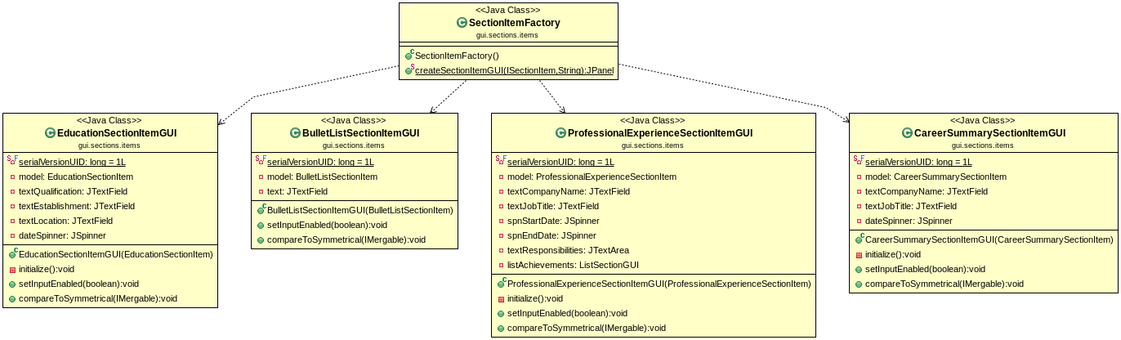
Class Name: BulletListSectionItemGUI
Responsibilities:  - Display the bullet list section item  - Update the back-end item based on user input | Collaborations:  - BulletListSectionItem

Class Name: ProfessionalExperienceSectionItemGUI
Responsibilities:  - Display the professional experience section item  - Update the back-end item based on user input | Collaborations:  - ListSectionGUI  - ProfessionalExperienceSectionItem

Class Name: CareerSummarySectionItemGUI
Responsibilities:  - Display the career summary section item | Collaborations:  - CareerSummarySectionItem

Class Name: EducationSectionItemGUI
Responsibilities:  - Display the education section item  - Update the back-end item based on user input | Collaborations:  - EducationSectionItem

Class Name: SectionItemFactory
Responsibilities:  - Create the appropriate GUI section item | Collaborations:  - BulletListSectionItemGUI  - ProfessionalExperienceSectionItemGUI  - CareerSummarySectionItemGUI  - EducationSectionItemGUI

GUI Selector
Classes of this package are responsible for the first application window, where the user chooses what he/she wants to do with the application.
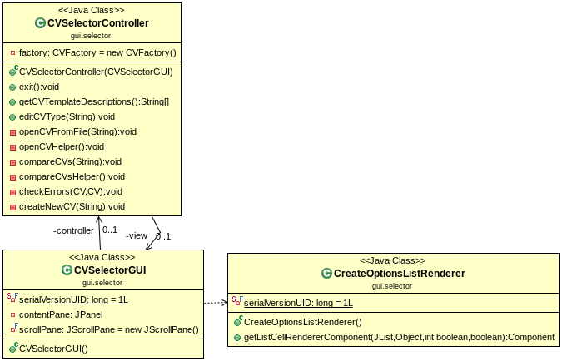
Class Name: CVSelectorGUI
Responsibilities:  - Display the initial window  - Read user choice | Collaborations:  - CVSelectorController  - CreateOptionsListRenderer

Class Name: CVSelectorController
Responsibilities:  - Create a new CV based on user input  - Inform the user if he does not select an option | Collaborations:  - CVEditorController  - CVSelectorGUI  - CV  - CVFactory  - CVSelectorGUI

Class Name: CreateOptionsListRenderer
Responsibilities:  - Display an image along with the text in available options | Collaborations:

GUI Merger
Classes in this package are responsible for the application window that mergers two Cvs.
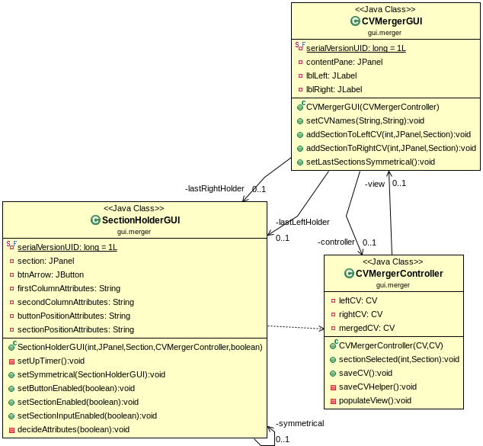
Class Name: SectionHolderGUI
Responsibilities:  - Display a GUI Section item along with a button to be able to select it.  - Compare and show the differences between the GUI Section Item and its symmetrical one. | Collaborations:  - CVMergerController

Class Name: CVMergerGUI
Responsibilities:  - Display two CVs. | Collaborations:  - SectionHolderGUI  - CVMergerController

Class Name: CVMergerController
Responsibilities:  - Merger two CV documents.  - Save the merged CV document. | Collaborations:  - CVMergerGUI

I/O Reader
Classes of this package are responsible for reading CVs from file.
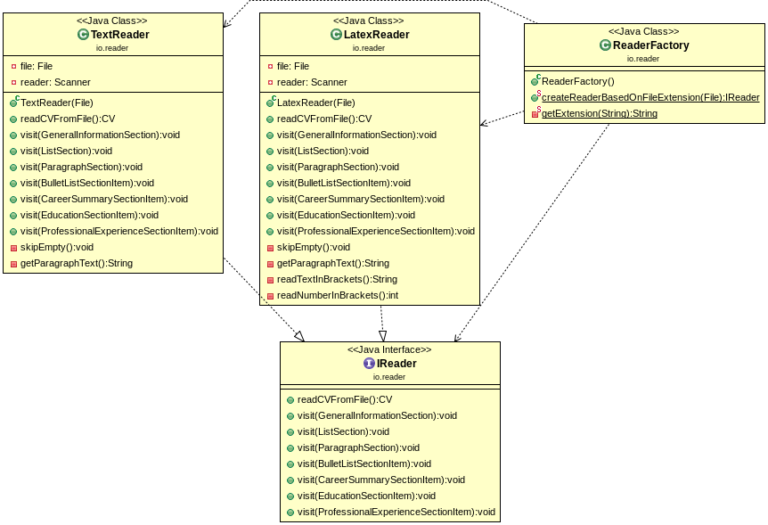
Class Name: IReader
Responsibilities:  - Provide an interface for file readers. | Collaborations:

Class Name: TextReader
Responsibilities:  - Read CVs from .txt files. | Collaborations:  - IReader

Class Name: LatexReader
Responsibilities:  - Read Cvs from .tex files. | Collaborations:  - IReader

Class Name: ReaderFactory
Responsibilities:  - Create the correct version of reader object. | Collaborations:  - Ireader  - TextReader  - LatexReader

I/O Writer
Classes of this package are responsible for writing CVs to file.
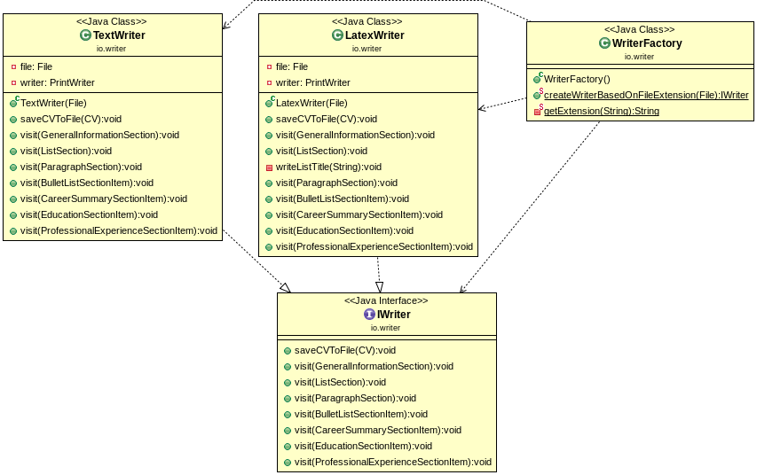
Class Name: IWriter
Responsibilities:  - Provide an iterface for writer objects. | Collaborations:

Class Name: TextWriter
Responsibilities:  - Write a CV to .txt file. | Collaborations:  - IWriter

Class Name: LatexWriter
Responsibilities:  - Write a CV to .tex file. | Collaborations:  - IWriter

Class Name: WriterFactory
Responsibilities:  - Create the correct version of writer object. | Collaborations:  - Iwriter  - TextWriter  - LatexWriter

Sections
Classes of this package are responsible for managing the CV sections.
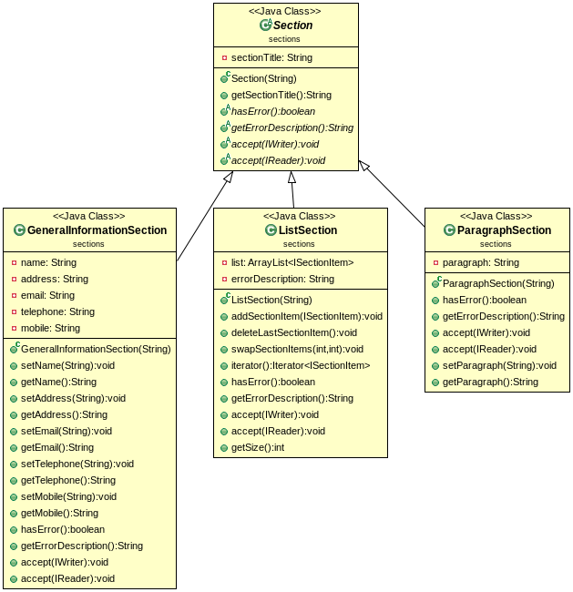
Class Name: Section
Responsibilities:  - Provide the base interface for the rest of the sections | Collaborations:

Class Name: GeneralInformationSection
Responsibilities:  - Manage the general information section of the CV | Collaborations:  - Section

Class Name: ListSection
Responsibilities:  - Manage a list section of the CV | Collaborations:  - Section

Class Name: ParagraphSection
Responsibilities:  - Manage a paragraph section of the CV | Collaborations:  - Section

Section Items
Classes of this package are responsible for managing the CV section items.
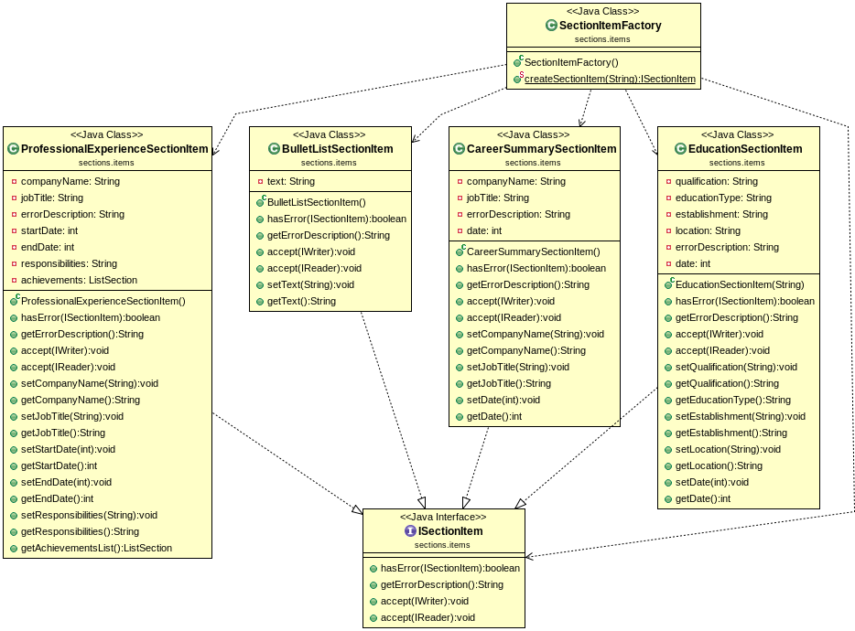

Class Name: ISectionItem
Responsibilities:  - Provide the base interface for the rest of the section items | Collaborations:

Class Name: BulletListSectionItem
Responsibilities:  - Manage a bullet list item | Collaborations:  - ISectionItem

Class Name: CareerSectionItem
Responsibilities:  - Manage a career section item | Collaborations:  - ISectionItem

Class Name: ProfessionalExperienceSectionItem
Responsibilities:  - Manage a professional experience section item | Collaborations:  - ISectionItem

Class Name: EducationSectionItem
Responsibilities:  - Manage an education section item | Collaborations:  - ISectionItem

Class Name: SectionItemFactory
Responsibilities:  - Create the appropriate section item | Collaborations:  - IsectionItem  - BulletListSectionItem  - CareerSectionItem  - ProfessionalExperienceSectionItem  - EducationSectionItem

Implementation
A printed copy of the source code (including the implementation of (1) classes and (2) tests) of this release is attached to the release report. The source code is further provided in a CD/DVD/USB-stick.

