1. ************* Module functions
2. functions.py:7:0: C0303: Trailing whitespace (trailing-whitespace)
3. functions.py:30:64: C0303: Trailing whitespace (trailing-whitespace)
4. functions.py:21:0: C0301: Line too long (108/100) (line-too-long)
5. functions.py:56:0: C0303: Trailing whitespace (trailing-whitespace)
6. functions.py:65:0: C0303: Trailing whitespace (trailing-whitespace)
7. functions.py:75:0: C0303: Trailing whitespace (trailing-whitespace)
8. functions.py:79:0: C0303: Trailing whitespace (trailing-whitespace)
9. functions.py:94:0: C0301: Line too long (111/100) (line-too-long)
10. functions.py:1:0: C0114: Missing module docstring (missing-module-docstring)
11. functions.py:33:4: R1705: Unnecessary "else" after "return" (no-else-return)
12. functions.py:67:4: R1705: Unnecessary "else" after "return" (no-else-return)
13. functions.py:85:4: C0103: Variable name "MTBF" doesn't conform to snake_case naming style (invalid-name)
14. functions.py:2:0: C0411: standard import "import math" should be placed before "import utils" (wrong-import-order)
16. -----------------------------------
17. Your code has been rated at 4.35/10
19. -----------------------------------
20. Your code has been rated at 4.35/10
22. PS C:\Users\s20153\BSI_zadania> python -m pylint .\utils.py
23. ************* Module utils
24. utils.py:1:0: C0114: Missing module docstring (missing-module-docstring)
25. ************* Module main
26. main.py:14:0: C0303: Trailing whitespace (trailing-whitespace)
27. main.py:16:0: C0303: Trailing whitespace (trailing-whitespace)
28. main.py:23:0: C0303: Trailing whitespace (trailing-whitespace)
29. main.py:29:0: C0303: Trailing whitespace (trailing-whitespace)
30. main.py:30:0: C0325: Unnecessary parens after 'if' keyword (superfluous-parens)
31. main.py:32:0: C0325: Unnecessary parens after 'if' keyword (superfluous-parens)
32. main.py:1:0: C0114: Missing module docstring (missing-module-docstring)
33. main.py:1:0: W0401: Wildcard import functions (wildcard-import)
34. main.py:3:0: C0103: Constant name "how_to_call" doesn't conform to UPPER_CASE naming style (invalid-name)
35. main.py:27:8: W0702: No exception type(s) specified (bare-except)
36. main.py:26:23: W0123: Use of eval (eval-used)
37. main.py:30:11: C0121: Comparison 'response != None' should be 'response is not None' (singleton-comparison)
38. main.py:32:11: C0123: Use isinstance() rather than type() for a typecheck. (unidiomatic-typecheck)
39. main.py:1:0: W0614: Unused import utils from wildcard import (unused-wildcard-import)
40. main.py:1:0: W0614: Unused import math from wildcard import (unused-wildcard-import)
41. main.py:1:0: W0614: Unused import z_1_b from wildcard import (unused-wildcard-import)
42. main.py:1:0: W0614: Unused import z_2 from wildcard import (unused-wildcard-import)
43. main.py:1:0: W0614: Unused import z_3 from wildcard import (unused-wildcard-import)
44. main.py:1:0: W0614: Unused import z_4 from wildcard import (unused-wildcard-import)
45. main.py:1:0: W0614: Unused import z_5 from wildcard import (unused-wildcard-import)

Wyniki testów :

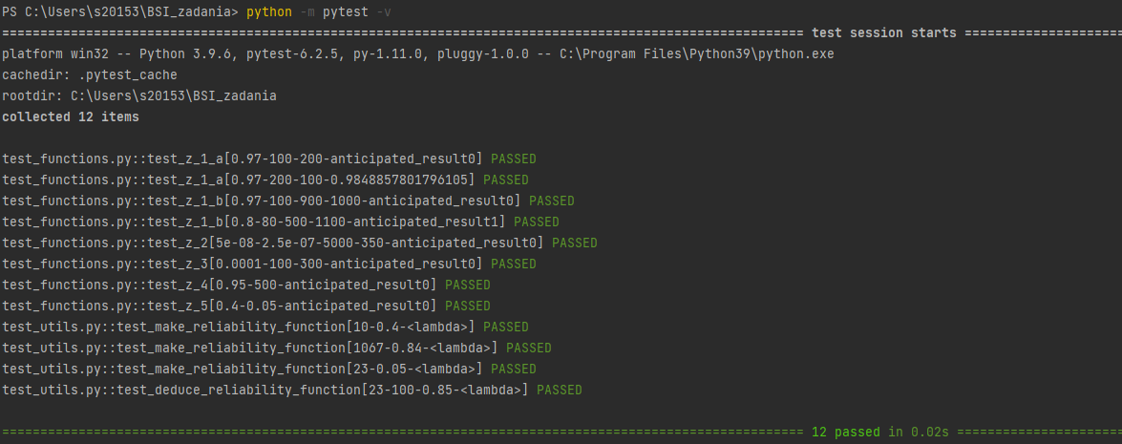

Nie testujemy main_loop. Mamy świadomość zagrożeń, jakie wprowadza, jednak zignorowaliśmy je, gdyż jest to projekt na studia.

Nie sprawdzamy, czy funkcje rzucają wyjątkami przy podaniu niepoprawnych danych; konkretnie: prawdopodobieństwo poza zakresem (0;1), ujemny czas, lub ilość sztuk. Powodem jest to, że w implementacji funkcji nie ma kodu rzucającego wyjątki. Jedyne rzucone będą wyjątkami związanymi z arytmetyką.