Phần 1:

1. B and C 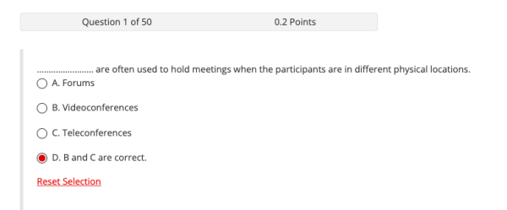

2. storage device

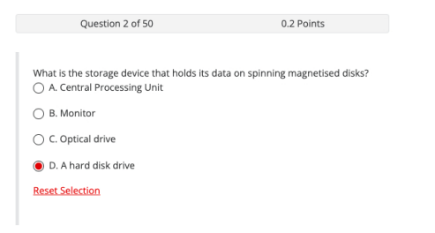

3. performs a similar

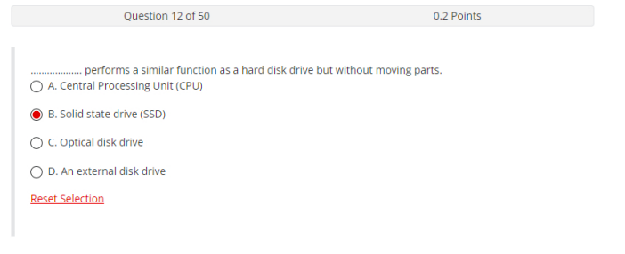

4. small part inside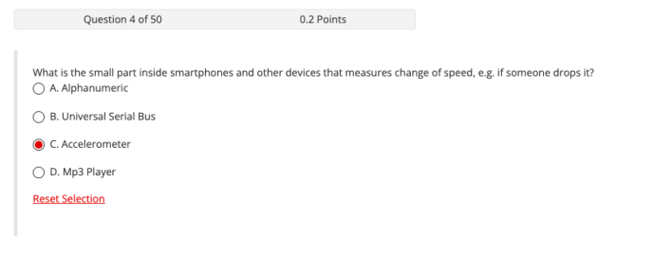5. box inside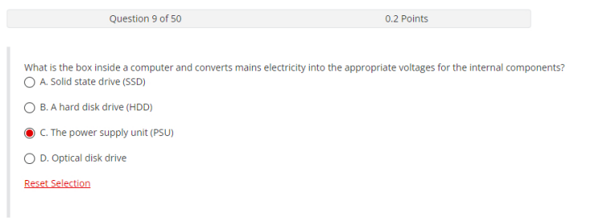6. PCs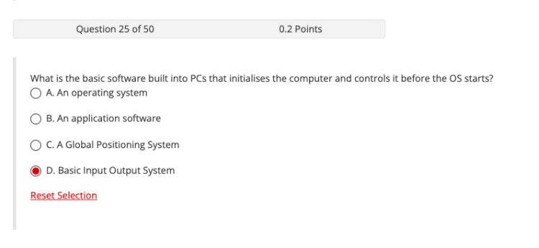

7. display

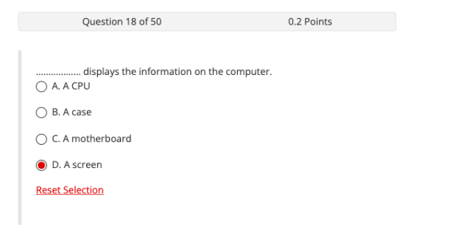

8. circuit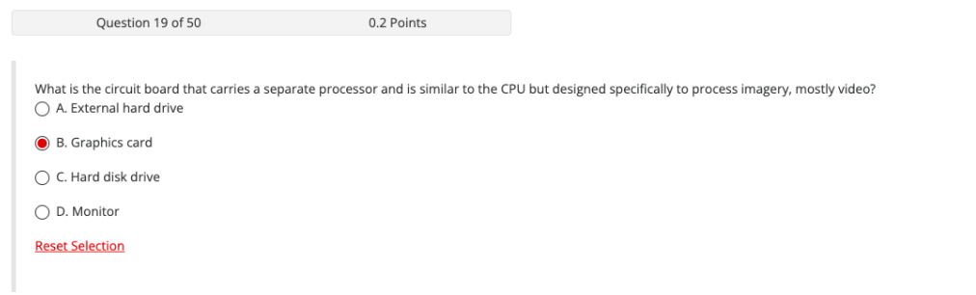6. PCs

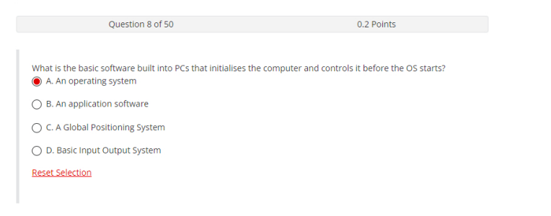

9. are glasses monitor

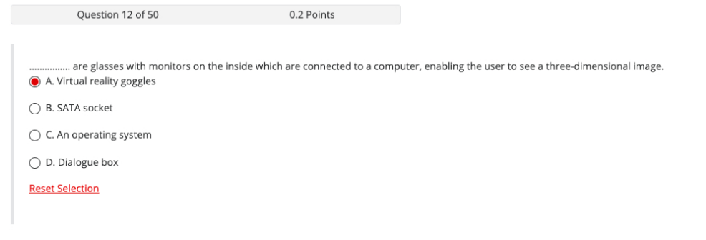

10. comprised only

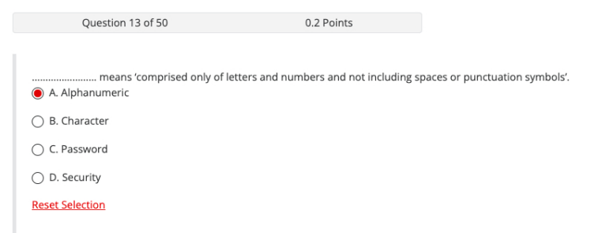

11. controls a computer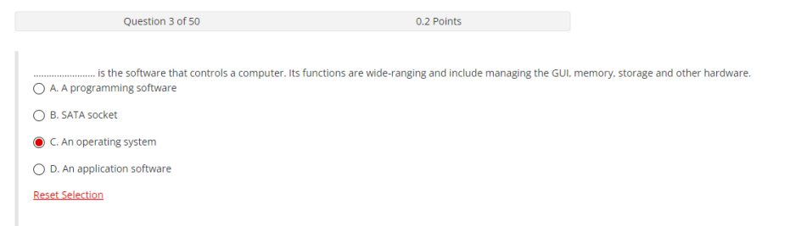

12. tell someone

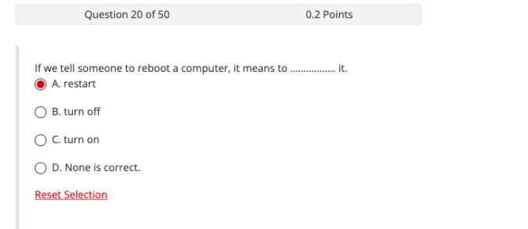

13. use radio

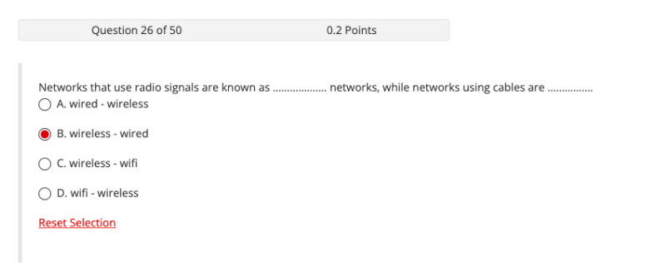

14. is the code

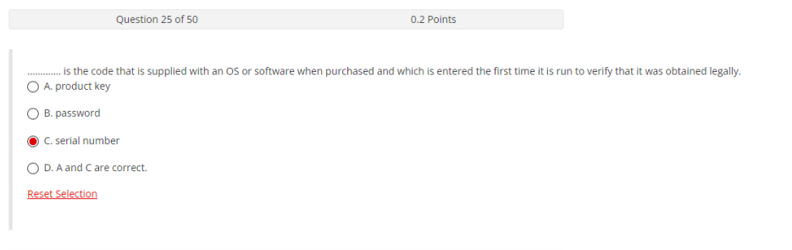

15. word below means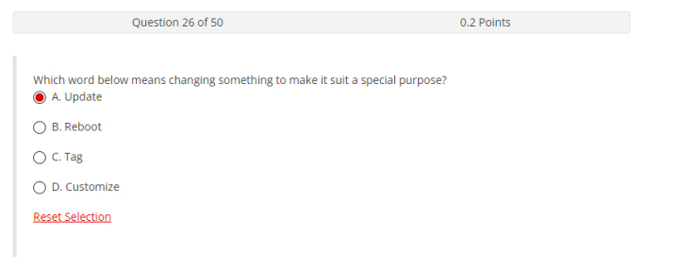

15. word below means

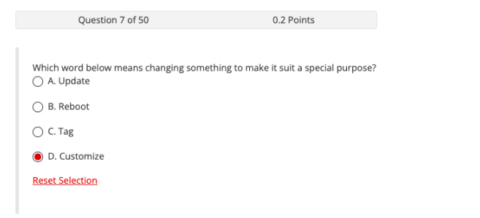

16. smallest unit

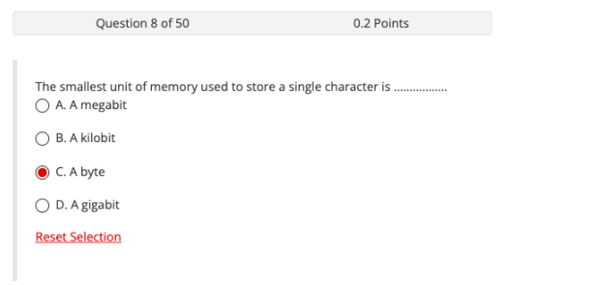

17. controls a computer

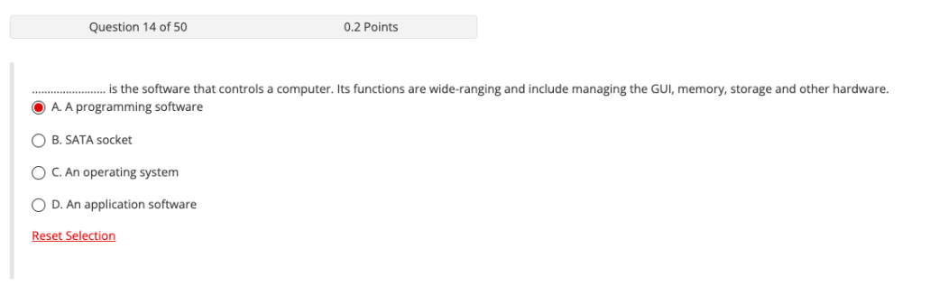

18. supervises technical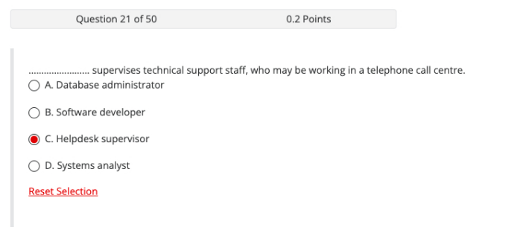

19. information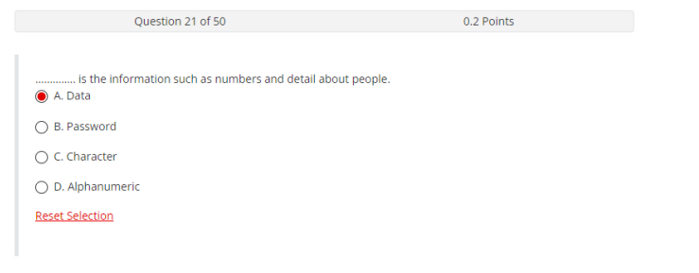

20. brain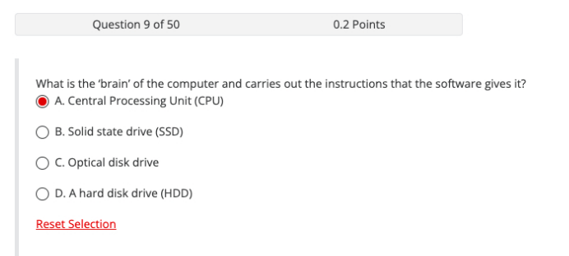

21. hard drive is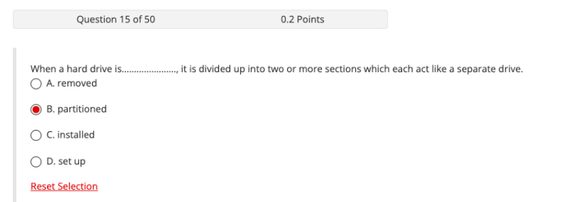22. Small circuit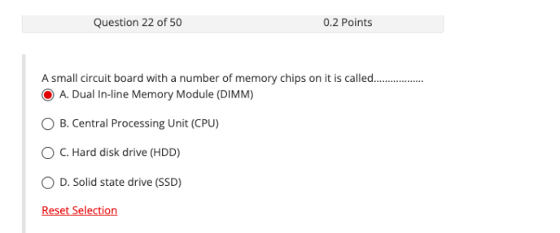

23. window that provides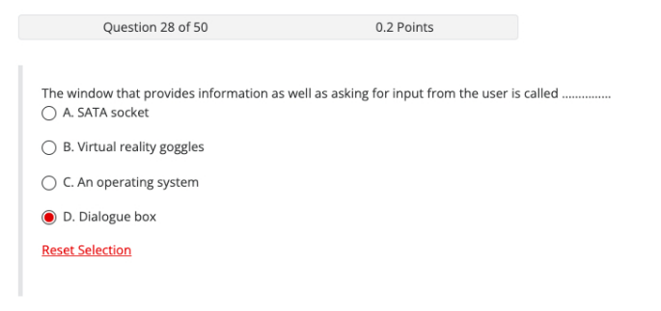

24. establish short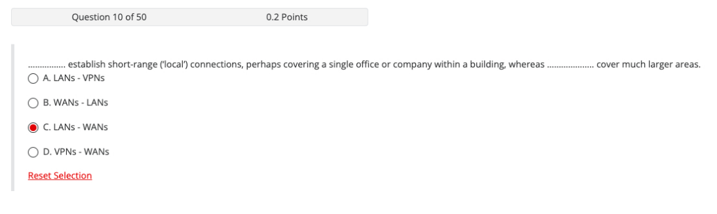

25. laser light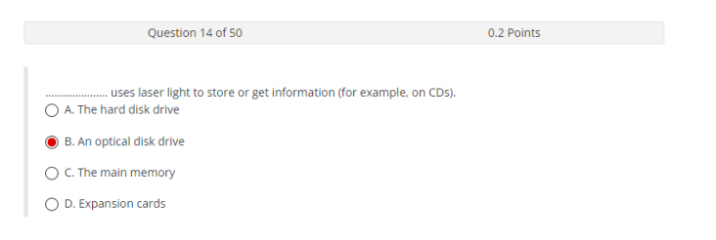

26. terms and conditions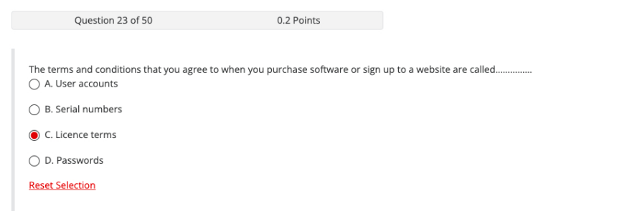

27. small box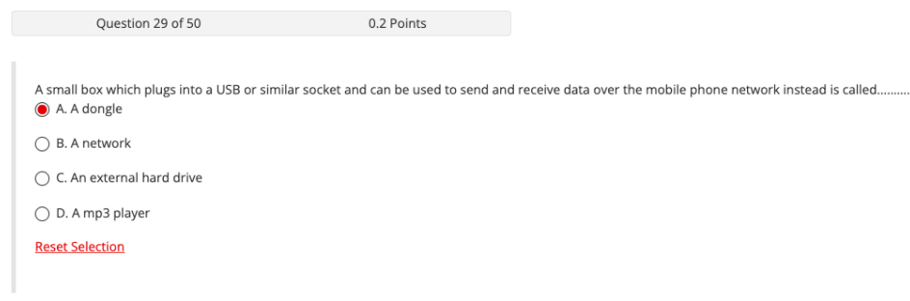

28. writes, tests

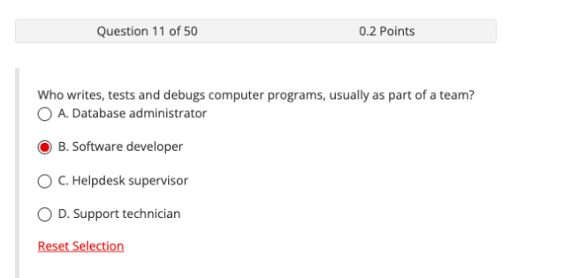

29. secret word

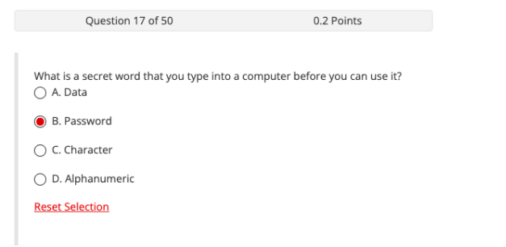

30. only letters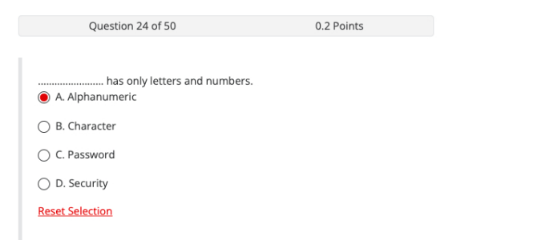

31. controls

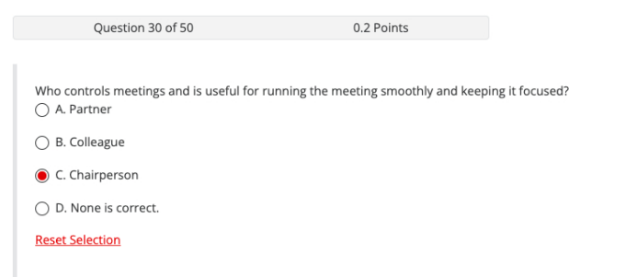

Phần 2:

1. A gateway is an entrance to another network .
2. Wireless networks have limited range.
3. I must update my calendar all the time.
4. Bandwidth and speed are the measures of network lattency.
5. Cloud computing allows share resources to colleagues.
6. A firewall access system protects from the public.
7. The main memory stores on the computer data.

Phần 3:

CPU Central Processing Unit.

RAM Random Access Memory.

CIO Chief Information Officer.

BIOS Basic input – Output System.

DIMM Double Inline Memory Modules.

WAN Wide Area Network.

BCC Blind Carbon Copy.

CC Carbon Copy.

OCR Optical Character Recognition.

USB Universal Serial Bus.

WWW World Wide Web.

HDD Hard Disk Drive.