Name : Chua Cheng Han

Class : CW1901A

|  |
| --- |
| Create a new repository |

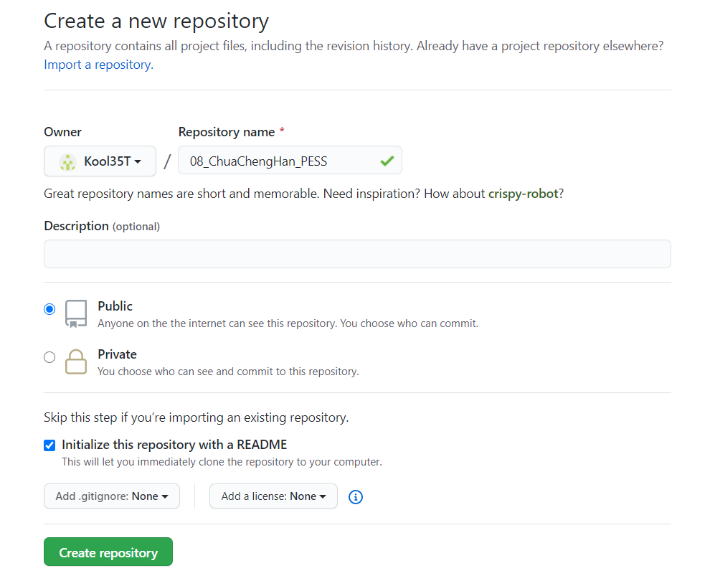

|  |
| --- |
| Invite Collaborator |

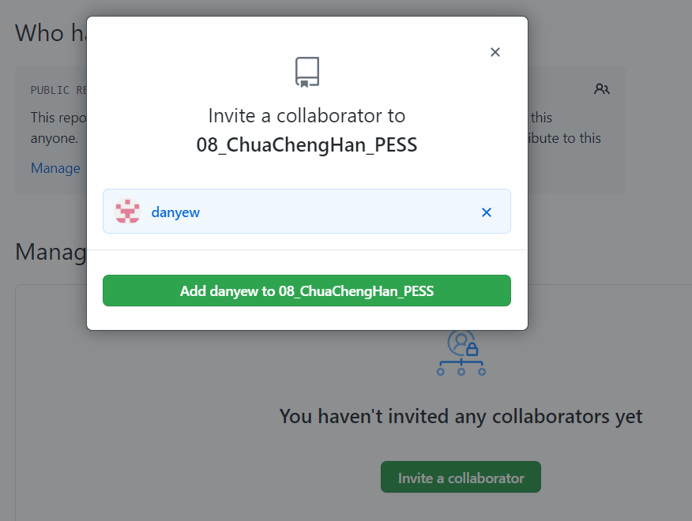

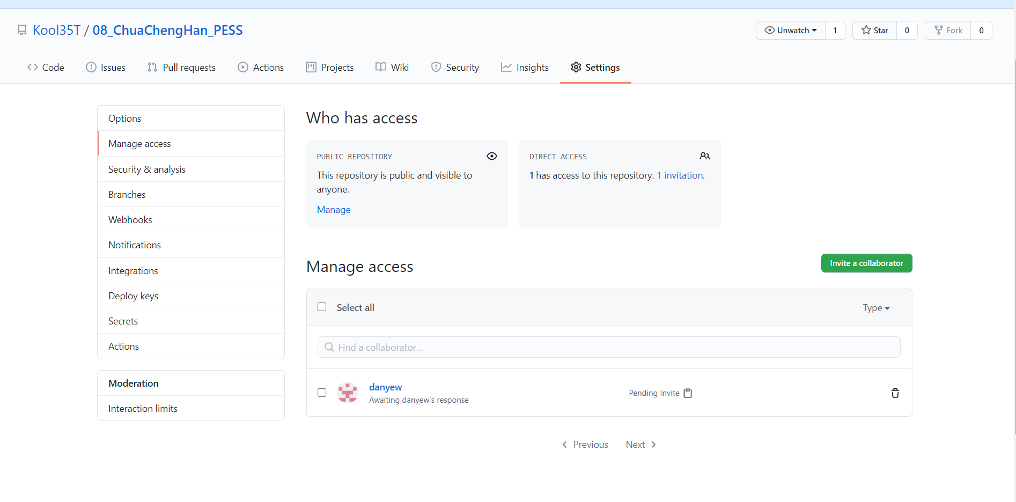

|  |
| --- |
| Clone |

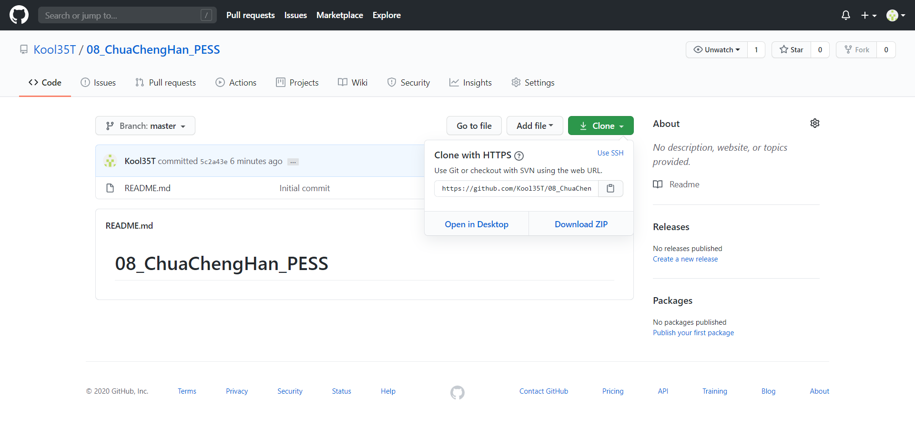

|  |
| --- |
| Open Github Desktop |

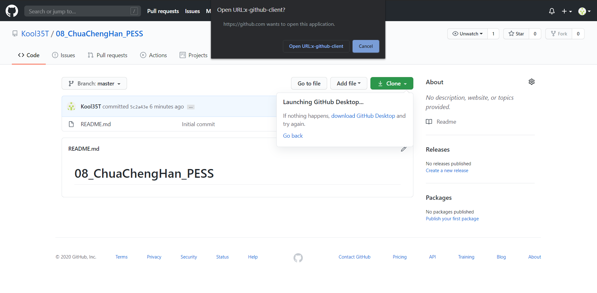

|  |
| --- |
| Clone a repository and choose the local path: C:\ xampp\htdocs\pess\08_ChuaChengHan_PESS |

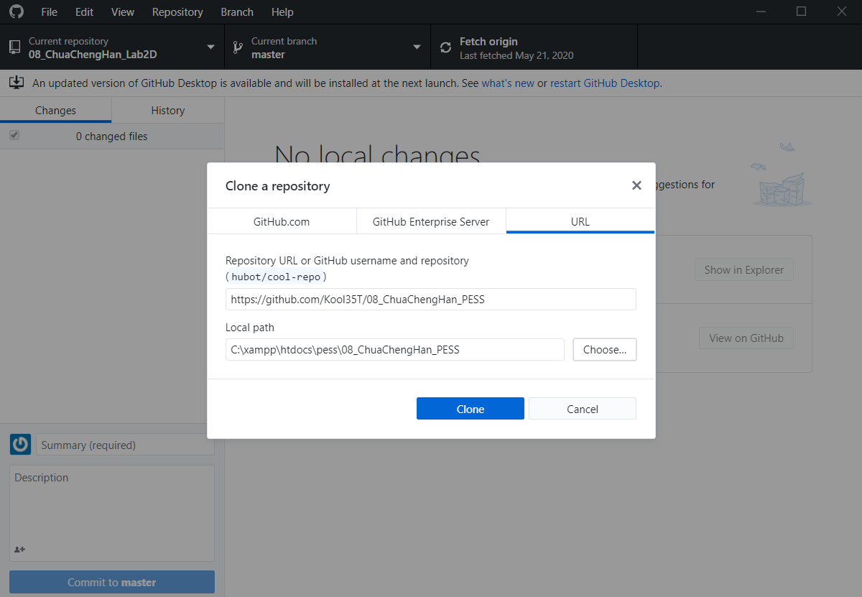

|  |
| --- |
| Commit to master |

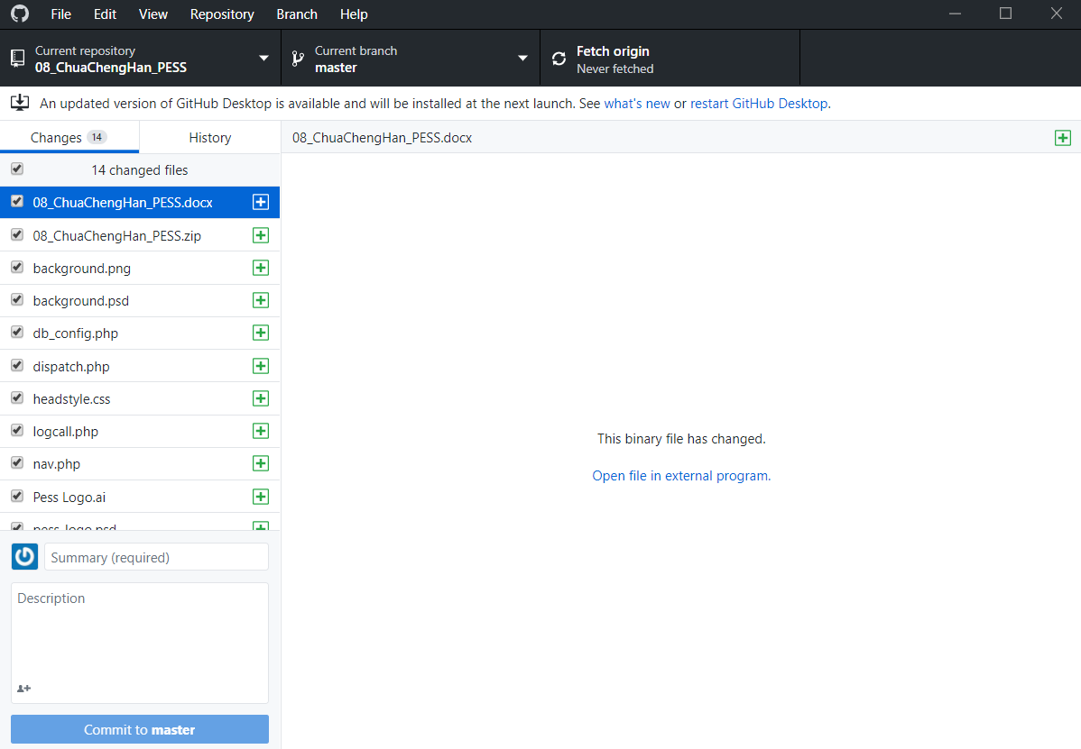

|  |
| --- |
| Click “Push origin” |

