1. Home:

* See the types of workouts plus description. On the see more. He can view more exercises.
* He can see the activities that the customer can do to improve her –weight: say running, cycling.
* The diet plan: once clicked it will take him to diet fragment: where she will be able to state what she hopes to incorporate
* into her diet; say: say: more vegetables.

1. Exercise

* The user can create an exercise plan for Herself
* Each day he incorporate her exercise plan.

1. Diet Plan

* Similar to diet plan

1. Meal

* She can be able to manage the kind of meals she ate from breakfast to supper and view the progress of it.

1. Profile:

* Age
* Weight
* Membership details
* BMI
* Logout
* Feedback(on the app, can be a good analytical tool to help the gym owner know how to make its services better)

Note: I was hoping is also the people to the gym can also use this app. Because they are still customers.

* Also the payment module.

ATTACHED DRAWABLES TO USE:

EXRECISES:

There can be small description of this:

**Say there are two types of exercise: Cardio exercise and body building exercise.**

-**Cardio exercise:** Cardio exercise uses the large muscles of your body in movement over a sustained period of time, keeping your heart rate to at least 50-percent of its maximum level.

- **Body building exercise**: build muscle.

* Exercise With equipment:

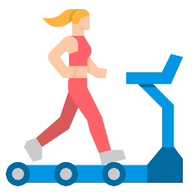1. **Treadmill**

DESCRIPTION: The treadmill has handrails, which is ideal if you're recovering from an injury. As with any heart-pumping cardio workout

DAILY ROUTINE: Exercise on a treadmill for 30 minutes, and you'll shed as much fat as you would breaking a sweat for an hour

BENEFITS:

* improve endurance
* control blood sugar
* promote healthier skin
* strengthen muscles
* decrease fatigue
* Spin bike exercise:

Riding a stationary exercise bike is an efficient and effective way to burn calories and body fat while strengthening your heart, lungs, and muscles. Cardio exercises.

DAILY workout: 30 minute spinning class

Benefits:

* Can help with weight loss
* Burns body fat
* Strengthens legs and lower body muscle
* Lifting weight

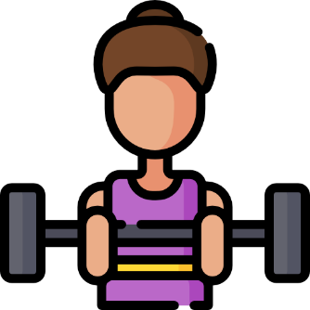

Description: use dumbells or lift weight.

* LUNGES

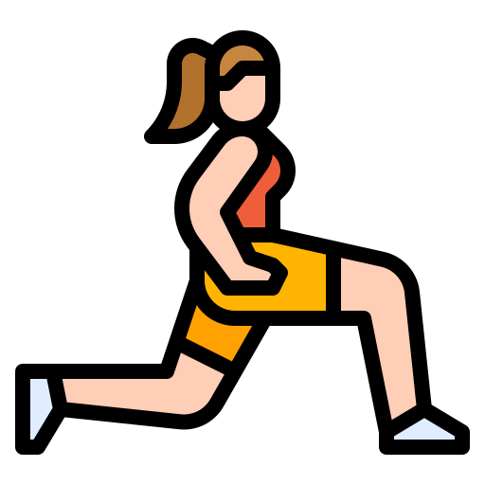

* PUSHUPS

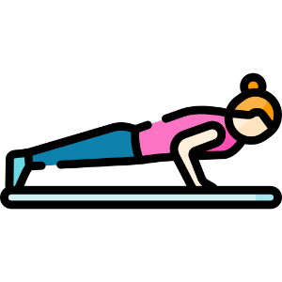

* SQUATS

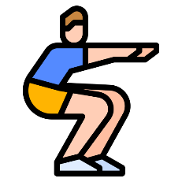

* ABDOMINAL CRUNCHES/SIT-UPS

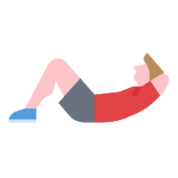

* YOGA/stretching exercises

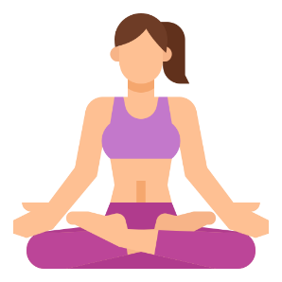LOTUS

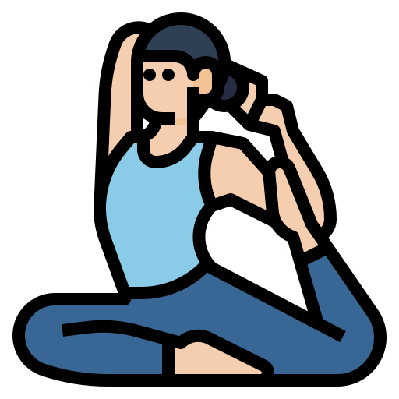 Pose 1

Pose2/Tree pose

* Jumping jacks

Description: Cardio exercise

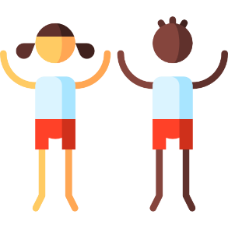

* Skipping rope

-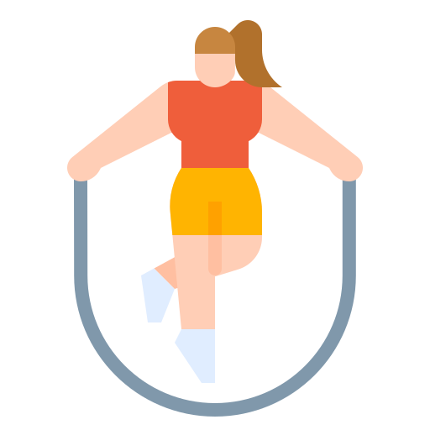

ACTIVITIES:

Swimming:



Biking

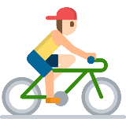

Dancing

