Installation

# Installing Java

The JRE( Java Runtime Environment) is usually already installed on the operating system. But with the JRE one can only run Java programs. To be able to develop programs we need the JDK (Java Development Kit).

The Website <http://www.oracle.com/technetwork/java/javase/downloads/> contains the Java downloads. I suggest installing the **newest JDK version**.

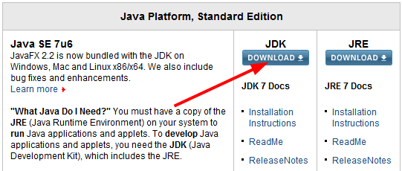Take not of where the installation directory. We will later need to direct Eclipse to this directory.

# Installing Eclipse (incl. e(fx)clipse)

You can also program Java with a simple text editor and the command line. But usually a development environment is used, which is essential for real projects.

We use Eclipse here as it is free and widely used (there are others, of course, such as Netbeans or Intellij IDEA).

Eclipse consists of a core program and countless (!) Plugins that can be installed as needed. We use a preconfigured package with Eclipse and the plugins that we need.

Go to <http://efxclipse.org/install.html> and download Eclipse 4.2 SDK as a "Preconfigured distro".

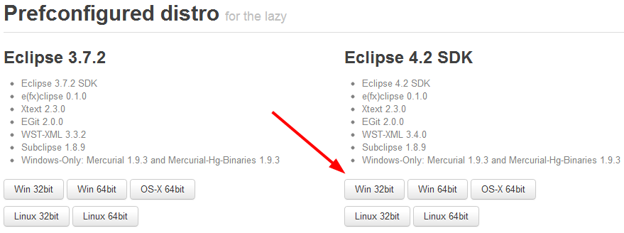

## Eclipse Configuration

Start Eclipse. Eclipse prompts you for the location where your projects are stored. This place is called a "workspace". One can easily have multiple workspaces.

Close the "Welcome" screen that appears after the start.

Open the Menu *Window | Preferences* and go to *Java | Installed JREs*. Click *Add ...* and select *Standard VM*. Then choose under *JRE Home* the directory where you installed the Java JDK and click Finish. Now select jdk1.7... as default. Delete the JRE that was previously there. Then click OK.

## Eclipse Projects

To create a new Eclipse project, select *File | New | Java Project*.

**Importing projects**

You will get some preconfigured Eclipse projects containing our exercises. These can be imported as follows: *File | Import ... | Existing Projects into Workspace*. If it's a zip file, select archive file and choose the file. Now, one or many projects from the zip file should appear below. Select the desired project and press Finish.

**Exporting projects**

To export an Eclipse project, click with the right mouse button on the project and select *Export ...* Select Archive File. Then you may specify the export location and file name.

# Installing JavaFX Scene Builder

For developing graphical user interfaces we use the JavaFX Scene Builder.

Download the latest JavaFX Scene Builder under <http://www.oracle.com/technetwork/java/javafx/downloads/> and install it.

