Instructions for Teachers

This document contains general information and hints to work with *GameGridKara* as a teacher.

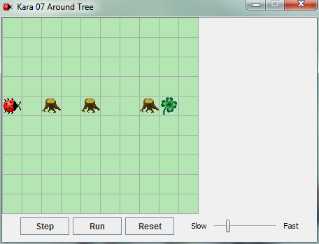**Example Task   
“Around Tree” from chapter 1:**

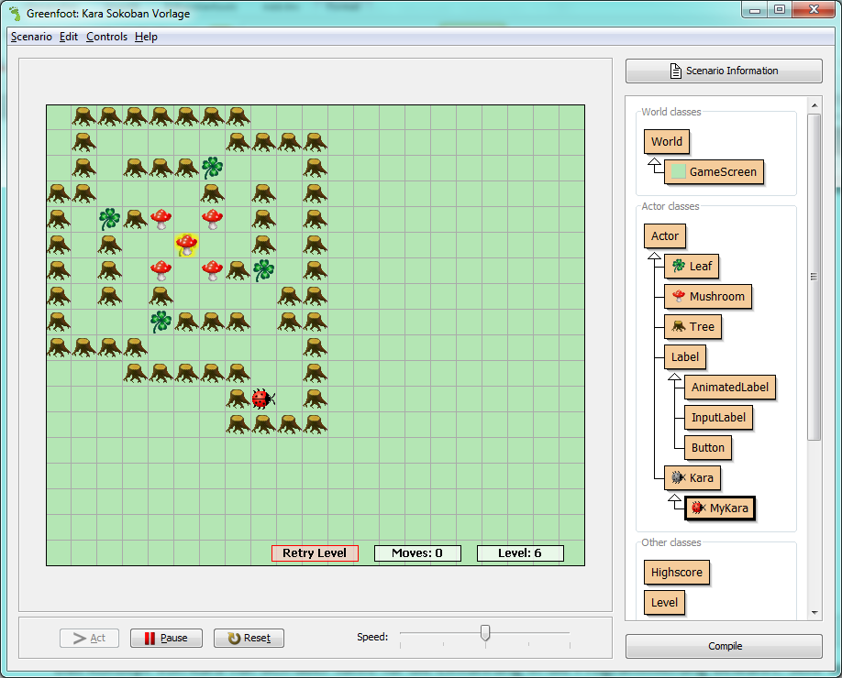

**Example from the game “Kara Sokoban” from chapter 4:   
(Kara must push all mushrooms on leafs)**

# Why JGameGrid and Kara

The **concept of Kara** has proven itself over years for the introduction to programming. Of great value are also the many exercises that already exist for Kara.

**JGameGrid** is a class library that allows easy development of interactive, graphical projects. JGameGrid can be used in **any IDE** (Integrated Development Environment) like **Eclipse, Netbeans or BlueJ**.

**🡺 GameGridKara combines the proven concept of Kara with JGameGrid’s flexibility and ease of use.**

As a teacher you can provide GameGridKara scenarios on any level of difficulty for students to work with. Afterwards, you could for example realize some advanced projects with JGameGrid (without Kara) or even without any such library. The advantage is that the students will already be familiar with the development environment.

# Instructions for GameGridKara

The scenarios exist as Eclipse projects. If you use Eclipse, it's easiest to just import the projects (***scenarios-chapter-1, scenarios-chapter-1-solutions, etc.***) into Eclipse.

(For other development environments you have to make shure that the two libraries *GameGridKara-x.x.x.jar and JGameGrid.x.x.jar* are in the classpath of the project.)

Each scenario has its own package with a MyKara class and a WorldSetup.txt file.

In each scenario, Kara, trees, leaves, etc. are built according to the WorldSetup.txt file.

## The Kara-Scenario

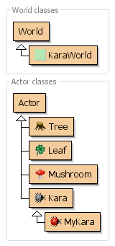The Kara-scenario and thus the possibilities of Kara remain the same for all exercises. The possibilities of Kara are the following):

|  |  |
| --- | --- |
| **Actions** | |
| move() | Kara makes a step in the current direction |
| turnLeft() | Kara turns left by 90 degrees |
| turnRight() | Kara turns right by 90 degrees |
| putLeaf() | Kara puts down a leaf |
| removeLeaf() | Kara picks up a leaf |

|  |  |
| --- | --- |
| **Sensors** | |
| onLeaf() | Kara checks if he stands on a leaf |
| treeFront() | Kara checks if there is a tree in front of him |
| treeLeft() | Kara checks if there is a tree on his left side |
| treeRight() | Kara checks if there is a tree on his right side |
| mushroomFront() | Kara checks if there is a mushroom in front of him |

In Chapter 4 Kara has a few additional methods so that a Sokoban game can be programmed.

In Chapter 5 Kara has a few additional methods to show messages and to ask the user for input.

### The classes Kara und MyKara

The most important classes are **Kara** and **MyKara**. The class Kara includes all the functionality of the beetle Kara as seen above. But **Programming is always done in the class MyKara** which, through inheritance, can accessed all the methods of Kara. Thus, the complexity of Kara’s methods are hidden from the students at first.

Later, the students may choose to find out how the methods were implemented in Kara itself. For this step it is recommended that they first examine the *Javadoc comments* of this class.

## Starting with Mouse Only

Objects of classes can be instantiated through *right-click*, *new ....()* and then be placed in the world.

On first contact with GameGridKara it is helpful to **only use the mouse**. If you right-click on a Kara-object, all available methods are shown and can be selected with the mouse. This way one can get accustomed with how Kara works.

## Programming

After the first contact with the mouse, the programming can be done inside the act()-method of MyKara. This method is executed when pressing the Step button. When the Run button is pressed, then the act()-method is called repeatedly.

# Tips

## The Editor

* Often the students have trouble with cleanly structuring the code. The editor helps you format by an auto-layout feature (Menu Source | Format).
* Ctrl-Space will open a pop-up for **auto completion**.
* Top right in the editor you can switch the view from *Source Code* to ***Documentation***.
* In the menu *Window | Preferences ...* the font size can be changed (e.g. for presentation with a projector).

## World Setup Files

In the file WorldSetup.txt the world can be defined. The file can also be named differently. If changed, you will have to adjust the constant **WORLD_SETUP_FILE** in the KaraWorld class.

A world setup file may contain multiple worlds. Each world must start with the following three lines:

World: [Your title]

X: [Width of the world]

Y: [Height of the world]

[Actors]

Actors are represented as follows:

* Tree by **#**
* Kara by **@**
* Leaf by **.**
* Mushroom by **$**
* A mushroom on a leaf by **\***
* Kara on a leaf by **+**

Tipp: Create the world inside GameGridKara and use right-click on the world | **saveWorldSetupToFile()** or **printWorldSetupToConsole()** to save the created world.

## Screen Output and User Input

There are several ways to interact with the user through GameGridKara over Input/Output:

* System.out.println(...) will write something on the console.
* With a Swing dialog (e.g. JOptionPane): This is used in ***KaraIO*** (Chapter 5).
* Drawing labels: This is the most complex version but also elegant as the input and output appears directly on the world and not in a pop-up dialog. An example can be found in ***KaraSokoban***.

## Sharing a Scenario with others (Deployment)

With GameGridKara, scenarios can easily be exported and shared with others:

In Eclipse choose the menu *File | Export ... | Java – Runnable Jar File*. Then you will need to select the correct *Launch Configuration*. It is probably the last launch configuration (if you have just launched the program before). The resulting jar file can be run on any system that has Java installed by double-clicking on the jar file.

# Recommended Books and Additional Links

I recommend taking a look at the book by Michael Kölling “Introduction to Programming with Greenfoot”. It can either be used as inspiration for the teacher or as a textbook for the whole class.

**Our Education Blog (where new versions of GameGridKara are announced)**

* <http://edu.makery.ch>

**Links for Kara:**

* GameGridKara: <http://www.swisseduc.ch/informatik/karatojava/gamegridkara/>
* GreenfootKara: <http://www.swisseduc.ch/informatik/karatojava/>greenfootkara/
* Worksheets and good exercises for Kara: <http://www.swisseduc.ch/informatik/karatojava/javakara/material/>

**Links for JGameGrid:**

* Main Website for JGameGrid: <http://www.gamegrid.ch>