EXAMINE VARIABLES=latitude
/PLOT BOXPLOT STEMLEAF HISTOGRAM NPPLOT
/COMPARE GROUPS
/STATISTICS DESCRIPTIVES
/CINTERVAL 95
/MISSING LISTWISE
/NOTOTAL.

Explore

Notes
Output Created |  | 20-JAN-2021 20:28:00
Comments
Input | Active Dataset | 数据集0
Input | Filter | <none>
Input | Weight | <none>
Input | Split File | <none>
Input | N of Rows in Working Data File | 22
Missing Value Handling | Definition of Missing | User-defined missing values for dependent variables are treated as missing.
Missing Value Handling | Cases Used | Statistics are based on cases with no missing values for any dependent variable or factor used.
Syntax |  | EXAMINE VARIABLES=latitude  /PLOT BOXPLOT STEMLEAF HISTOGRAM NPPLOT  /COMPARE GROUPS  /STATISTICS DESCRIPTIVES  /CINTERVAL 95  /MISSING LISTWISE  /NOTOTAL.
Resources | Processor Time | 00:00:02.56
Resources | Elapsed Time | 00:00:01.34

Case Processing Summary
 | Cases
 | Valid |  | Missing |  | Total
 | N | Percent | N | Percent | N | Percent
latitude | 22 | 100.0% | 0 | 0.0% | 22 | 100.0%

Descriptives
 |  |  | Statistic | Std. Error
latitude | Mean |  | 36.1818 | 1.95140
latitude | 95% Confidence Interval for Mean | Lower Bound | 32.1237
latitude | 95% Confidence Interval for Mean | Upper Bound | 40.2400
latitude | 5% Trimmed Mean |  | 37.4596
latitude | Median |  | 40.0000
latitude | Variance |  | 83.775
latitude | Std. Deviation |  | 9.15286
latitude | Minimum |  | 3.00
latitude | Maximum |  | 45.00
latitude | Range |  | 42.00
latitude | Interquartile Range |  | 7.00
latitude | Skewness |  | -2.699 | .491
latitude | Kurtosis |  | 8.217 | .953

Tests of Normality
 | Kolmogorov-Smirnovª |  |  | Shapiro-Wilk
 | Statistic | df | Sig. | Statistic | df | Sig.
latitude | .344 | 22 | .000 | .637 | 22 | .000

a. Lilliefors Significance Correction

latitude

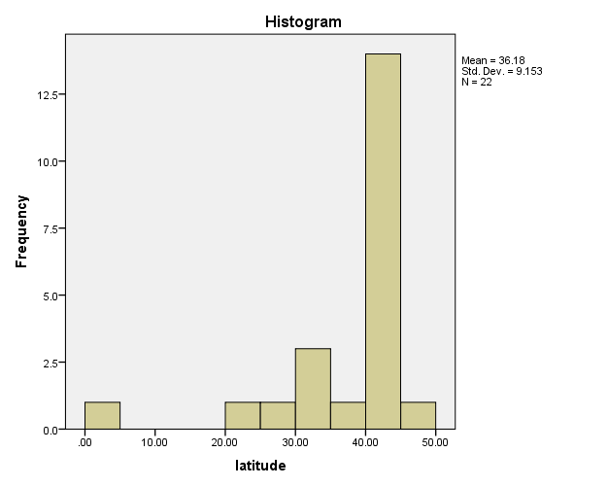

latitude Stem-and-Leaf Plot

Frequency Stem & Leaf

2.00 Extremes (=<20)
1.00 2 . 9
3.00 3 . 333
1.00 3 . 7
14.00 4 . 00000000000003
1.00 4 . 5

Stem width: 10.00
Each leaf: 1 case(s)

